Figure 7
Fixed Broadband Availability Measured by Location and Block as of December 31, 2023
(Units in thousands. Includes services of at least 100 Mbps downstream and 20 Mbps upstream)

 |  | Aggregation By Location |  | Aggregation By Block |  | Difference
Technology | Total Units | Units Covered | Ratio | Units Covered | Ratio | Difference | Ratio
Any Technology | 163,295 | 163,250 | 1.00 | 163,276 | 1.00 | 26 | 0.00
Satellite | 163,295 | 162,783 | 1.00 | 162,971 | 1.00 | 188 | 0.00
Terrestrial | 163,295 | 154,669 | 0.95 | 159,203 | 0.97 | 4,535 | 0.03
Fixed Wireless | 163,295 | 72,697 | 0.45 | 116,373 | 0.71 | 43,676 | 0.27
Licensed | 163,295 | 59,464 | 0.36 | 108,575 | 0.66 | 49,110 | 0.30
Unlicensed | 163,295 | 25,845 | 0.16 | 32,063 | 0.20 | 6,218 | 0.04
Wireline | 163,295 | 150,009 | 0.92 | 155,206 | 0.95 | 5,197 | 0.03
Copper Wire¹ | 163,295 | 7,106 | 0.04 | 29,796 | 0.18 | 22,691 | 0.14
Coaxial Cable | 163,295 | 138,789 | 0.85 | 145,267 | 0.89 | 6,478 | 0.04
Optical Carrier | 163,295 | 74,671 | 0.46 | 102,436 | 0.63 | 27,764 | 0.17
¹ Other is summarized with Copper Wire.
Note: The Aggregation by Location columns sum the number of units reported with terrestrial fixed broadband service of at least 100 Mbps downstream and 20 Mbps
upstream. The Aggregation by Block columns attempt to replicate the methodology used prior to the BDC where an entire block was counted as served if at least
one location in that block was reported as served. The Difference column shows the number of locations without service that would have been counted as served using
the block-level methodology. Numbers may not sum due to rounding.
Source: FCC Broadband Data Collection.
Figure 8
Availability of Fixed Broadband by Speed and Technology as of December 31, 2023

 | Share of units in Broadband Serviceable Locations with speeds of at least
Technology | 200 kbps in  at least One Direction | 10 Mbps Down  and 1 Mbps Up | 25 Mbps Down  and 3 Mbps Up | 100 Mbps Down  and 20 Mbps Up | 940 Mbps Down  and 500 Mbps Up
Any Technology | 100.0 | 100.0 | 100.0 | 100.0 | 47.1
Satellite | 100.0 | 100.0 | 100.0 | 99.7 | 0.0
Terrestrial | 99.0 | 98.3 | 96.8 | 94.7 | 47.1
Fixed Wireless | 87.6 | 74.4 | 66.7 | 44.5 | 3.1
Licensed | 84.2 | 68.3 | 59.1 | 36.4 | 0.4
Unlicensed | 25.9 | 25.5 | 24.1 | 15.8 | 2.7
Wireline | 95.3 | 94.5 | 93.0 | 91.9 | 45.3
Copper Wire¹ | 44.1 | 35.3 | 21.2 | 4.4 | 0.0
Coaxial Cable | 85.4 | 85.4 | 85.3 | 85.0 | 3.6
Optical Carrier | 45.8 | 45.8 | 45.8 | 45.7 | 43.7
¹ Other is summarized with Copper Wire.
Source: FCC Broadband Data Collection.

Figure 9
Availability of Terrestrial Fixed Broadband by State as of December 31, 2023
(Units in thousands)

 |  | At least 200 kbps in  at least One Direction |  | At least 10 Mbps Down  and 1 Mbps Up |  | At least 25 Mbps Down  and 3 Mbps Up |  | At least 100 Mbps Down  and 20 Mbps Up |  | At least 940 Mbps Down  and 500 Mbps Up
State | Units | Units | Ratio | Units | Ratio | Units | Ratio | Units | Ratio | Units | Ratio
Alabama | 2,725 | 2,630 | 0.97 | 2,575 | 0.95 | 2,448 | 0.90 | 2,359 | 0.87 | 1,152 | 0.42
Alaska | 390 | 365 | 0.94 | 355 | 0.91 | 331 | 0.85 | 306 | 0.78 | 13 | 0.03
American Samoa | 10 | 10 | 1.00 | 10 | 1.00 | 10 | 1.00 | 2 | 0.20 | 0 | 0.00
Arizona | 3,504 | 3,484 | 0.99 | 3,457 | 0.99 | 3,414 | 0.97 | 3,290 | 0.94 | 627 | 0.18
Arkansas | 1,645 | 1,607 | 0.98 | 1,575 | 0.96 | 1,521 | 0.92 | 1,451 | 0.88 | 854 | 0.52
California | 16,192 | 16,109 | 0.99 | 16,089 | 0.99 | 16,032 | 0.99 | 15,856 | 0.98 | 5,880 | 0.36
Colorado | 2,862 | 2,838 | 0.99 | 2,826 | 0.99 | 2,806 | 0.98 | 2,715 | 0.95 | 1,118 | 0.39
Connecticut | 1,696 | 1,691 | 1.00 | 1,689 | 1.00 | 1,685 | 0.99 | 1,683 | 0.99 | 1,011 | 0.60
Delaware | 532 | 532 | 1.00 | 531 | 1.00 | 530 | 1.00 | 523 | 0.98 | 256 | 0.48
District of Columbia | 381 | 381 | 1.00 | 381 | 1.00 | 381 | 1.00 | 381 | 1.00 | 212 | 0.56
Florida | 11,411 | 11,338 | 0.99 | 11,255 | 0.99 | 11,128 | 0.98 | 10,986 | 0.96 | 4,654 | 0.41
Georgia | 5,074 | 5,011 | 0.99 | 4,946 | 0.97 | 4,845 | 0.95 | 4,738 | 0.93 | 2,393 | 0.47
Guam | 46 | 45 | 0.99 | 45 | 0.99 | 45 | 0.99 | 43 | 0.94 | 8 | 0.17
Hawaii | 616 | 609 | 0.99 | 608 | 0.99 | 604 | 0.98 | 603 | 0.98 | 239 | 0.39
Idaho | 917 | 902 | 0.98 | 892 | 0.97 | 880 | 0.96 | 807 | 0.88 | 321 | 0.35
Illinois | 6,169 | 6,143 | 1.00 | 6,122 | 0.99 | 6,067 | 0.98 | 5,941 | 0.96 | 2,133 | 0.35
Indiana | 3,358 | 3,339 | 0.99 | 3,311 | 0.99 | 3,261 | 0.97 | 3,180 | 0.95 | 1,711 | 0.51
Iowa | 1,678 | 1,676 | 1.00 | 1,673 | 1.00 | 1,650 | 0.98 | 1,601 | 0.95 | 839 | 0.50
Kansas | 1,505 | 1,500 | 1.00 | 1,495 | 0.99 | 1,471 | 0.98 | 1,420 | 0.94 | 862 | 0.57
Kentucky | 2,329 | 2,280 | 0.98 | 2,242 | 0.96 | 2,161 | 0.93 | 2,080 | 0.89 | 1,663 | 0.71
Louisiana | 2,410 | 2,312 | 0.96 | 2,263 | 0.94 | 2,185 | 0.91 | 2,081 | 0.86 | 794 | 0.33
Maine | 829 | 817 | 0.99 | 807 | 0.97 | 792 | 0.96 | 753 | 0.91 | 303 | 0.37
Maryland | 2,774 | 2,765 | 1.00 | 2,753 | 0.99 | 2,741 | 0.99 | 2,718 | 0.98 | 1,559 | 0.56
Massachusetts | 3,386 | 3,380 | 1.00 | 3,377 | 1.00 | 3,372 | 1.00 | 3,366 | 0.99 | 1,458 | 0.43
Michigan | 5,230 | 5,154 | 0.99 | 5,083 | 0.97 | 4,991 | 0.95 | 4,889 | 0.93 | 1,649 | 0.32
Minnesota | 2,874 | 2,858 | 0.99 | 2,840 | 0.99 | 2,795 | 0.97 | 2,735 | 0.95 | 1,941 | 0.68
Mississippi | 1,648 | 1,579 | 0.96 | 1,537 | 0.93 | 1,442 | 0.88 | 1,388 | 0.84 | 893 | 0.54
Missouri | 3,181 | 3,149 | 0.99 | 3,129 | 0.98 | 3,072 | 0.97 | 2,944 | 0.93 | 2,115 | 0.67
Montana | 626 | 604 | 0.96 | 587 | 0.94 | 556 | 0.89 | 500 | 0.80 | 143 | 0.23
Nebraska | 1,016 | 1,011 | 1.00 | 1,006 | 0.99 | 992 | 0.98 | 960 | 0.95 | 617 | 0.61

Figure 9 - Continued
Availability of Terrestrial Fixed Broadband by State as of December 31, 2023
(Units in thousands)

 |  | At least 200 kbps in  at least One Direction |  | At least 10 Mbps Down  and 1 Mbps Up |  | At least 25 Mbps Down  and 3 Mbps Up |  | At least 100 Mbps Down  and 20 Mbps Up |  | At least 940 Mbps Down  and 500 Mbps Up
State | Units | Units | Ratio | Units | Ratio | Units | Ratio | Units | Ratio | Units | Ratio
Nevada | 1,437 | 1,434 | 1.00 | 1,431 | 1.00 | 1,427 | 0.99 | 1,416 | 0.99 | 1,336 | 0.93
New Hampshire | 733 | 728 | 0.99 | 719 | 0.98 | 712 | 0.97 | 707 | 0.96 | 353 | 0.48
New Jersey | 4,279 | 4,268 | 1.00 | 4,266 | 1.00 | 4,253 | 0.99 | 4,248 | 0.99 | 2,540 | 0.59
New Mexico | 1,104 | 1,089 | 0.99 | 1,058 | 0.96 | 1,020 | 0.92 | 968 | 0.88 | 239 | 0.22
New York | 9,297 | 9,246 | 0.99 | 9,215 | 0.99 | 9,178 | 0.99 | 9,159 | 0.99 | 6,378 | 0.69
North Carolina | 5,550 | 5,502 | 0.99 | 5,467 | 0.99 | 5,323 | 0.96 | 5,180 | 0.93 | 2,279 | 0.41
North Dakota | 476 | 476 | 1.00 | 475 | 1.00 | 473 | 0.99 | 472 | 0.99 | 298 | 0.63
Northern Mariana Isl | 11 | 11 | 0.98 | 11 | 0.98 | 11 | 0.98 | 11 | 0.98 | 2 | 0.15
Ohio | 5,916 | 5,877 | 0.99 | 5,847 | 0.99 | 5,789 | 0.98 | 5,667 | 0.96 | 2,594 | 0.44
Oklahoma | 2,082 | 2,068 | 0.99 | 2,053 | 0.99 | 2,021 | 0.97 | 1,940 | 0.93 | 976 | 0.47
Oregon | 2,073 | 2,048 | 0.99 | 2,028 | 0.98 | 1,977 | 0.95 | 1,918 | 0.93 | 864 | 0.42
Pennsylvania | 6,512 | 6,440 | 0.99 | 6,377 | 0.98 | 6,273 | 0.96 | 6,198 | 0.95 | 3,021 | 0.46
Puerto Rico | 1,408 | 1,406 | 1.00 | 1,401 | 0.99 | 1,398 | 0.99 | 1,385 | 0.98 | 901 | 0.64
Rhode Island | 542 | 541 | 1.00 | 540 | 1.00 | 540 | 1.00 | 539 | 0.99 | 406 | 0.75
South Carolina | 2,810 | 2,793 | 0.99 | 2,774 | 0.99 | 2,733 | 0.97 | 2,671 | 0.95 | 1,173 | 0.42
South Dakota | 507 | 504 | 0.99 | 501 | 0.99 | 492 | 0.97 | 479 | 0.94 | 240 | 0.47
Tennessee | 3,514 | 3,477 | 0.99 | 3,437 | 0.98 | 3,381 | 0.96 | 3,329 | 0.95 | 2,062 | 0.59
Texas | 13,862 | 13,740 | 0.99 | 13,682 | 0.99 | 13,521 | 0.98 | 13,299 | 0.96 | 7,898 | 0.57
Utah | 1,392 | 1,384 | 0.99 | 1,379 | 0.99 | 1,366 | 0.98 | 1,343 | 0.96 | 817 | 0.59
Vermont | 378 | 377 | 1.00 | 359 | 0.95 | 351 | 0.93 | 324 | 0.86 | 178 | 0.47
Virgin Islands | 34 | 34 | 1.00 | 34 | 1.00 | 34 | 1.00 | 34 | 1.00 | 0 | 0.00
Virginia | 4,155 | 4,086 | 0.98 | 4,020 | 0.97 | 3,932 | 0.95 | 3,862 | 0.93 | 2,136 | 0.51
Washington | 3,651 | 3,617 | 0.99 | 3,576 | 0.98 | 3,499 | 0.96 | 3,364 | 0.92 | 1,274 | 0.35
West Virginia | 1,023 | 934 | 0.91 | 909 | 0.89 | 828 | 0.81 | 788 | 0.77 | 233 | 0.23
Wisconsin | 3,211 | 3,184 | 0.99 | 3,156 | 0.98 | 3,060 | 0.95 | 2,790 | 0.87 | 1,193 | 0.37
Wyoming | 323 | 311 | 0.96 | 306 | 0.95 | 300 | 0.93 | 278 | 0.86 | 100 | 0.31
Total | 163,295 | 161,694 | 0.99 | 160,481 | 0.98 | 158,099 | 0.97 | 154,669 | 0.95 | 76,909 | 0.47
# = Rounds to Zero.
Note: Satellite services are excluded from this analysis. Numbers may not sum to totals due to rounding.
Source: FCC Broadband Data Collection.

Figure 10
Availability of Mobile Broadband by State as of December 31, 2023
(Units in thousands)

 |  | At least 3G  (200 Kbps Down  and 50 Kbps Up) |  | At least 4G LTE  (5 Mbps Down  and 1 Mbps Up) |  | At least 5G-NR  (7 Mbps Down  and 1 Mbps Up) |  | At least 5G-NR  (35 Mbps Down  and 3 Mbps Up)
State | Units | Units | Ratio | Units | Ratio | Units | Ratio | Units | Ratio
Alabama | 2,725 | 2,717 | 1.00 | 2,717 | 1.00 | 2,576 | 0.95 | 2,371 | 0.87
Alaska | 390 | 372 | 0.95 | 362 | 0.93 | 315 | 0.81 | 259 | 0.66
American Samoa | 10 | 10 | 1.00 | 10 | 1.00 | 8 | 0.79 | 7 | 0.74
Arizona | 3,504 | 3,498 | 1.00 | 3,497 | 1.00 | 3,398 | 0.97 | 3,368 | 0.96
Arkansas | 1,645 | 1,624 | 0.99 | 1,624 | 0.99 | 1,536 | 0.93 | 1,382 | 0.84
California | 16,192 | 16,147 | 1.00 | 16,146 | 1.00 | 16,049 | 0.99 | 15,893 | 0.98
Colorado | 2,862 | 2,841 | 0.99 | 2,838 | 0.99 | 2,734 | 0.96 | 2,668 | 0.93
Connecticut | 1,696 | 1,692 | 1.00 | 1,692 | 1.00 | 1,651 | 0.97 | 1,574 | 0.93
Delaware | 532 | 530 | 1.00 | 530 | 1.00 | 526 | 0.99 | 513 | 0.96
District of Columbia | 381 | 381 | 1.00 | 381 | 1.00 | 381 | 1.00 | 381 | 1.00
Florida | 11,411 | 11,393 | 1.00 | 11,393 | 1.00 | 11,352 | 0.99 | 11,167 | 0.98
Georgia | 5,074 | 5,068 | 1.00 | 5,068 | 1.00 | 4,898 | 0.97 | 4,604 | 0.91
Guam | 46 | 45 | 0.98 | 45 | 0.98 | 38 | 0.82 | 34 | 0.75
Hawaii | 616 | 607 | 0.99 | 607 | 0.99 | 603 | 0.98 | 586 | 0.95
Idaho | 917 | 903 | 0.98 | 903 | 0.98 | 869 | 0.95 | 831 | 0.91
Illinois | 6,169 | 6,167 | 1.00 | 6,167 | 1.00 | 6,050 | 0.98 | 5,856 | 0.95
Indiana | 3,358 | 3,355 | 1.00 | 3,355 | 1.00 | 3,241 | 0.97 | 3,065 | 0.91
Iowa | 1,678 | 1,675 | 1.00 | 1,675 | 1.00 | 1,595 | 0.95 | 1,420 | 0.85
Kansas | 1,505 | 1,504 | 1.00 | 1,504 | 1.00 | 1,422 | 0.94 | 1,292 | 0.86
Kentucky | 2,329 | 2,273 | 0.98 | 2,273 | 0.98 | 1,975 | 0.85 | 1,774 | 0.76
Louisiana | 2,410 | 2,405 | 1.00 | 2,405 | 1.00 | 2,337 | 0.97 | 2,218 | 0.92
Maine | 829 | 807 | 0.97 | 807 | 0.97 | 738 | 0.89 | 599 | 0.72
Maryland | 2,774 | 2,762 | 1.00 | 2,762 | 1.00 | 2,753 | 0.99 | 2,693 | 0.97
Massachusetts | 3,386 | 3,376 | 1.00 | 3,376 | 1.00 | 3,322 | 0.98 | 3,186 | 0.94
Michigan | 5,230 | 5,201 | 0.99 | 5,201 | 0.99 | 5,015 | 0.96 | 4,769 | 0.91
Minnesota | 2,874 | 2,866 | 1.00 | 2,866 | 1.00 | 2,739 | 0.95 | 2,582 | 0.90
Mississippi | 1,648 | 1,641 | 1.00 | 1,641 | 1.00 | 1,513 | 0.92 | 1,306 | 0.79
Missouri | 3,181 | 3,168 | 1.00 | 3,168 | 1.00 | 3,029 | 0.95 | 2,796 | 0.88
Montana | 626 | 608 | 0.97 | 608 | 0.97 | 573 | 0.92 | 538 | 0.86
Nebraska | 1,016 | 1,013 | 1.00 | 1,013 | 1.00 | 880 | 0.87 | 794 | 0.78

Figure 10 - Continued
Availability of Mobile Broadband by State as of December 31, 2023
(Units in thousands)

 |  | At least 3G  (200 Kbps Down  and 50 Kbps Up) |  | At least 4G LTE  (5 Mbps Down  and 1 Mbps Up) |  | At least 5G-NR  (7 Mbps Down  and 1 Mbps Up) |  | At least 5G-NR  (35 Mbps Down  and 3 Mbps Up)
State | Units | Units | Ratio | Units | Ratio | Units | Ratio | Units | Ratio
Nevada | 1,437 | 1,436 | 1.00 | 1,435 | 1.00 | 1,426 | 0.99 | 1,417 | 0.99
New Hampshire | 733 | 724 | 0.99 | 724 | 0.99 | 651 | 0.89 | 550 | 0.75
New Jersey | 4,279 | 4,277 | 1.00 | 4,277 | 1.00 | 4,265 | 1.00 | 4,214 | 0.98
New Mexico | 1,104 | 1,095 | 0.99 | 1,093 | 0.99 | 1,041 | 0.94 | 987 | 0.89
New York | 9,297 | 9,243 | 0.99 | 9,243 | 0.99 | 9,092 | 0.98 | 8,819 | 0.95
North Carolina | 5,550 | 5,505 | 0.99 | 5,505 | 0.99 | 5,282 | 0.95 | 4,880 | 0.88
North Dakota | 476 | 475 | 1.00 | 475 | 1.00 | 425 | 0.89 | 393 | 0.82
Northern Mariana Isl | 11 | 11 | 0.99 | 11 | 0.99 | 9 | 0.80 | 9 | 0.77
Ohio | 5,916 | 5,895 | 1.00 | 5,895 | 1.00 | 5,826 | 0.98 | 5,661 | 0.96
Oklahoma | 2,082 | 2,077 | 1.00 | 2,077 | 1.00 | 2,010 | 0.97 | 1,881 | 0.90
Oregon | 2,073 | 2,056 | 0.99 | 2,056 | 0.99 | 2,005 | 0.97 | 1,948 | 0.94
Pennsylvania | 6,512 | 6,470 | 0.99 | 6,470 | 0.99 | 6,323 | 0.97 | 6,151 | 0.94
Puerto Rico | 1,408 | 1,405 | 1.00 | 1,404 | 1.00 | 1,395 | 0.99 | 1,262 | 0.90
Rhode Island | 542 | 542 | 1.00 | 542 | 1.00 | 537 | 0.99 | 518 | 0.96
South Carolina | 2,810 | 2,807 | 1.00 | 2,807 | 1.00 | 2,720 | 0.97 | 2,569 | 0.91
South Dakota | 507 | 504 | 0.99 | 504 | 0.99 | 468 | 0.92 | 423 | 0.83
Tennessee | 3,514 | 3,474 | 0.99 | 3,474 | 0.99 | 3,298 | 0.94 | 3,084 | 0.88
Texas | 13,862 | 13,846 | 1.00 | 13,845 | 1.00 | 13,627 | 0.98 | 13,316 | 0.96
Utah | 1,392 | 1,388 | 1.00 | 1,388 | 1.00 | 1,376 | 0.99 | 1,365 | 0.98
Vermont | 378 | 358 | 0.95 | 358 | 0.95 | 276 | 0.73 | 217 | 0.58
Virgin Islands | 34 | 34 | 1.00 | 34 | 1.00 | 32 | 0.93 | 3 | 0.09
Virginia | 4,155 | 4,112 | 0.99 | 4,112 | 0.99 | 3,901 | 0.94 | 3,654 | 0.88
Washington | 3,651 | 3,623 | 0.99 | 3,623 | 0.99 | 3,570 | 0.98 | 3,475 | 0.95
West Virginia | 1,023 | 920 | 0.90 | 920 | 0.90 | 827 | 0.81 | 738 | 0.72
Wisconsin | 3,211 | 3,190 | 0.99 | 3,190 | 0.99 | 2,949 | 0.92 | 2,713 | 0.84
Wyoming | 323 | 318 | 0.98 | 317 | 0.98 | 280 | 0.87 | 249 | 0.77
Total | 163,295 | 162,432 | 0.99 | 162,412 | 0.99 | 157,723 | 0.97 | 151,021 | 0.92
# = Rounds to Zero.
Note: Numbers may not sum to totals due to rounding.
Source: FCC Broadband Data Collection.

Figure 11
Connections over 200 kbps in at Least One Direction 2019-2023
(in thousands)

 | 2019 | 2020 |  | 2021 |  | 2022 |  | 2023
Technology | Dec | Jun | Dec | Jun | Dec | Jun | Dec | Jun | Dec
Total | 466,320 | 480,200 | 490,890 | 500,260 | 510,200 | 518,230 | 527,297 | 535,300 | 544,312
Mobile | 352,010 | 361,740 | 369,640 | 376,840 | 384,420 | 391,876 | 399,258 | 405,795 | 413,283
Fixed | 114,310 | 118,460 | 121,250 | 123,430 | 125,780 | 126,354 | 128,038 | 129,505 | 131,028
Note: Some previously-published data may have been revised. Numbers may not sum to totals due to rounding.
Source: FCC Form 477.

Figure 12
Residential Connections over 200 kbps in at Least One Direction 2019-2023
(in thousands)

 | 2019 | 2020 |  | 2021 |  | 2022 |  | 2023
Technology | Dec | Jun | Dec | Jun | Dec | Jun | Dec | Jun | Dec
Total | 388,360 | 403,230 | 407,650 | 415,260 | 436,580 | 442,439 | 448,601 | 454,210 | 460,431
Mobile | 283,640 | 294,300 | 296,030 | 301,680 | 320,780 | 325,832 | 330,065 | 334,582 | 339,571
Fixed | 104,720 | 108,920 | 111,620 | 113,580 | 115,790 | 116,608 | 118,536 | 119,627 | 120,860
Note: Some previously-published data may have been revised. Numbers may not sum to totals due to rounding.
Source: FCC Form 477.

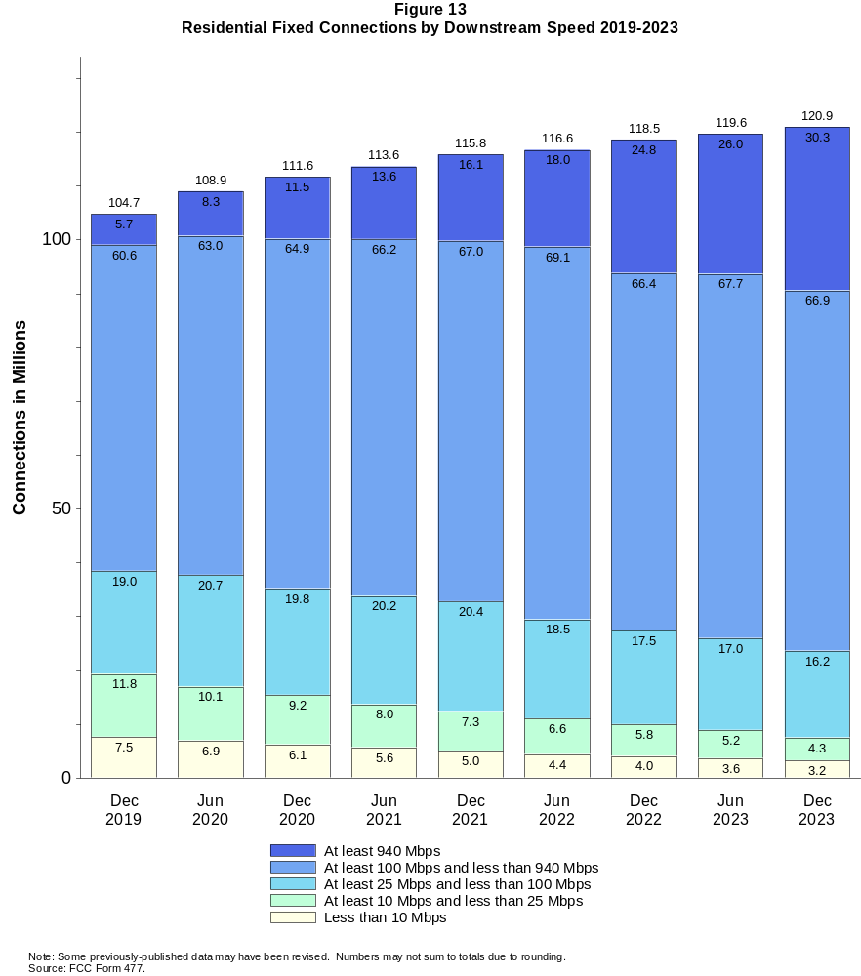

Figure 14
Distribution of Fixed Connections over 200 kbps in at Least One Direction as of December 31, 2023

 | Downstream Speed
Upstream Speed | Less than 10 Mbps | At least 10 Mbps  and less than 25 Mbps | At least 25 Mbps  and less than 100 Mbps | At least 100 Mbps  and less than 940 Mbps | At least 940 Mbps | Total
Less than 1 Mbps | 2,418 | 535 | # | 0 | # | 2,954
At least 1 Mbps & Less than 3 Mbps | 1,048 | 3,331 | 639 | 4 | # | 5,022
At least 3 Mbps & Less than 20 Mbps | 102 | 957 | 16,210 | 34,340 | 410 | 52,019
At least 20 Mbps & Less than 500 Mbps | 81 | 72 | 1,610 | 33,591 | 15,075 | 50,428
At least 500 Mbps | 0 | 1 | 1 | 4,384 | 16,219 | 20,605
Total | 3,649 | 4,896 | 18,461 | 72,319 | 31,704 | 131,028

Percentages

Less than 1 Mbps | 1.8 | 0.4 | 0.0 | 0.0 | 0.0 | 2.3
At least 1 Mbps & Less than 3 Mbps | 0.8 | 2.5 | 0.5 | 0.0 | 0.0 | 3.8
At least 3 Mbps & Less than 20 Mbps | 0.1 | 0.7 | 12.4 | 26.2 | 0.3 | 39.7
At least 20 Mbps & Less than 500 Mbps | 0.1 | 0.1 | 1.2 | 25.6 | 11.5 | 38.5
At least 500 Mbps | 0.0 | 0.0 | 0.0 | 3.3 | 12.4 | 15.7
Total | 2.8 | 3.7 | 14.1 | 55.2 | 24.2 | 100.0
# = Rounds to zero.
Note: Numbers may not sum to totals due to rounding.
Source: FCC Form 477.

Figure 15
Distribution of Residential Fixed Connections over 200 kbps in at Least One Direction as of December 31, 2023

 | Downstream Speed
Upstream Speed | Less than 10 Mbps | At least 10 Mbps  and less than 25 Mbps | At least 25 Mbps  and less than 100 Mbps | At least 100 Mbps  and less than 940 Mbps | At least 940 Mbps | Total
Less than 1 Mbps | 2,075 | 499 | # | 0 | # | 2,574
At least 1 Mbps & Less than 3 Mbps | 918 | 2,897 | 442 | 4 | # | 4,261
At least 3 Mbps & Less than 20 Mbps | 82 | 820 | 14,449 | 32,427 | 410 | 48,188
At least 20 Mbps & Less than 500 Mbps | 76 | 47 | 1,279 | 30,287 | 14,599 | 46,287
At least 500 Mbps | 0 | 1 | 1 | 4,207 | 15,341 | 19,549
Total | 3,151 | 4,264 | 16,170 | 66,924 | 30,349 | 120,860

Percentages

Less than 1 Mbps | 1.7 | 0.4 | 0.0 | 0.0 | 0.0 | 2.1
At least 1 Mbps & Less than 3 Mbps | 0.8 | 2.4 | 0.4 | 0.0 | 0.0 | 3.5
At least 3 Mbps & Less than 20 Mbps | 0.1 | 0.7 | 12.0 | 26.8 | 0.3 | 39.9
At least 20 Mbps & Less than 500 Mbps | 0.1 | 0.0 | 1.1 | 25.1 | 12.1 | 38.3
At least 500 Mbps | 0.0 | 0.0 | 0.0 | 3.5 | 12.7 | 16.2
Total | 2.6 | 3.5 | 13.4 | 55.4 | 25.1 | 100.0
# = Rounds to zero.
Note: Numbers may not sum to totals due to rounding.
Source: FCC Form 477.

Figure 16
Connections over 200 kbps in at Least One Direction by Technology 2019-2023
(in thousands)

 | 2019 | 2020 |  | 2021 |  | 2022 |  | 2023
Technology | Dec | Jun | Dec | Jun | Dec | Jun | Dec | Jun | Dec
Total | 466,320 | 480,200 | 490,890 | 500,260 | 510,200 | 518,230 | 527,297 | 535,300 | 544,312
Mobile | 352,010 | 361,740 | 369,640 | 376,840 | 384,420 | 391,876 | 399,258 | 405,795 | 413,283
Fixed | 114,310 | 118,460 | 121,250 | 123,430 | 125,780 | 126,354 | 128,038 | 129,505 | 131,028
Copper Wire¹ | 20,755 | 20,174 | 19,327 | 18,620 | 17,412 | 15,644 | 14,712 | 13,236 | 11,850
Coaxial Cable | 72,516 | 75,986 | 77,909 | 79,330 | 80,232 | 80,022 | 80,110 | 79,454 | 79,078
Optical Carrier | 17,376 | 18,459 | 19,945 | 21,120 | 23,338 | 24,984 | 26,343 | 28,310 | 30,216
Satellite | 1,975 | 1,993 | 1,931 | 1,910 | 1,873 | 2,031 | 2,039 | 2,026 | 2,128
Fixed Wireless | 1,687 | 1,853 | 2,140 | 2,445 | 2,923 | 3,672 | 4,834 | 6,480 | 7,757
Licensed | - | - | - | - | - | 1,954 | 3,213 | 4,889 | 6,251
Unlicensed | - | - | - | - | - | 1,718 | 1,621 | 1,591 | 1,507
¹ Power Line and Other are summarized with Copper Wire for confidentiality reasons. See Technical Notes at the end of the report for a description of FCC
Form 477 technology categories and other reporting requirements.
* = Data withheld for confidentiality reasons. # = Rounds to zero. - = Data was not collected.
Note: Some previously-published data may have been revised. Numbers may not sum to totals due to rounding.
Source: FCC Form 477.

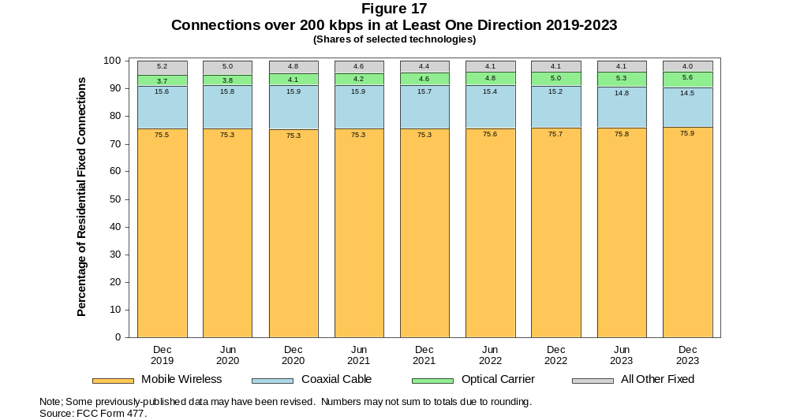

Figure 18
Residential Connections over 200 kbps in at Least One Direction by Technology 2019-2023
(in thousands)

 | 2019 | 2020 |  | 2021 |  | 2022 |  | 2023
Technology | Dec | Jun | Dec | Jun | Dec | Jun | Dec | Jun | Dec
Total | 388,360 | 403,230 | 407,650 | 415,260 | 436,580 | 442,439 | 448,601 | 454,210 | 460,431
Mobile | 283,640 | 294,300 | 296,030 | 301,680 | 320,780 | 325,832 | 330,065 | 334,582 | 339,571
Fixed | 104,720 | 108,920 | 111,620 | 113,580 | 115,790 | 116,608 | 118,536 | 119,627 | 120,860
Copper Wire¹ | 18,237 | 17,718 | 16,983 | 16,344 | 15,269 | 13,978 | 13,101 | 11,858 | 10,636
Coaxial Cable | 67,141 | 70,710 | 72,543 | 73,844 | 74,599 | 74,442 | 74,533 | 73,885 | 73,386
Optical Carrier | 16,011 | 16,986 | 18,384 | 19,414 | 21,531 | 22,941 | 24,456 | 26,255 | 28,000
Satellite | 1,795 | 1,815 | 1,752 | 1,728 | 1,692 | 1,841 | 1,949 | 1,929 | 2,037
Fixed Wireless | 1,535 | 1,694 | 1,959 | 2,251 | 2,701 | 3,406 | 4,498 | 5,701 | 6,800
Licensed | - | - | - | - | - | 1,841 | 3,022 | 4,260 | 5,431
Unlicensed | - | - | - | - | - | 1,565 | 1,476 | 1,440 | 1,368
¹ Power Line and Other are summarized with Copper Wire for confidentiality reasons. See Technical Notes at the end of the report for a description of FCC
Form 477 technology categories and other reporting requirements.
* = Data withheld for confidentiality reasons. # = Rounds to zero. - = Data was not collected.
Note: Some previously-published data may have been revised. Numbers may not sum to totals due to rounding.
Source: FCC Form 477.

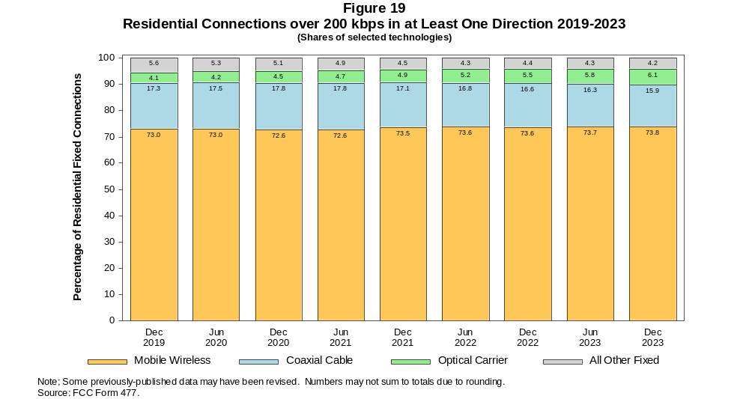

Figure 20
Fixed Connections at Least 10 Mbps Downstream and 1 Mbps Upstream by Technology 2019-2023
(in thousands)

 | 2019 | 2020 |  | 2021 |  | 2022 |  | 2023
Technology | Dec | Jun | Dec | Jun | Dec | Jun | Dec | Jun | Dec
Total | 103,610 | 109,180 | 112,450 | 115,770 | 118,770 | 120,370 | 122,664 | 124,658 | 126,844
Copper Wire¹ | 12,011 | 12,735 | 12,086 | 12,347 | 11,681 | 10,683 | 10,318 | 9,425 | 8,571
Coaxial Cable | 71,934 | 75,391 | 77,513 | 79,035 | 79,956 | 79,676 | 79,819 | 79,276 | 78,965
Optical Carrier | 16,854 | 18,008 | 19,555 | 20,813 | 23,058 | 24,820 | 26,198 | 28,182 | 30,097
Satellite | 1,737 | 1,778 | 1,727 | 1,717 | 1,700 | 1,863 | 1,935 | 1,929 | 2,049
Fixed Wireless | 1,078 | 1,263 | 1,564 | 1,860 | 2,379 | 3,328 | 4,396 | 5,846 | 7,161
Licensed | - | - | - | - | - | 1,907 | 3,052 | 4,601 | 5,947
Unlicensed | - | - | - | - | - | 1,421 | 1,344 | 1,245 | 1,215
¹ Power Line and Other are summarized with Copper Wire for confidentiality reasons. See Technical Notes at the end of the report for a description of FCC
Form 477 technology categories and other reporting requirements.
* = Data withheld for confidentiality reasons. # = Rounds to zero. - = Data was not collected.
Note: Some previously-published data may have been revised. Numbers may not sum to totals due to rounding.
Source: FCC Form 477.

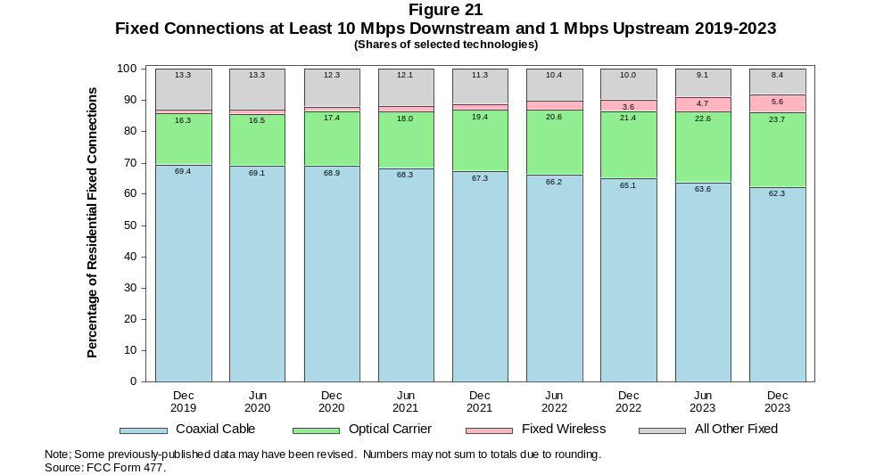

Figure 22
Residential Fixed Connections at Least 10 Mbps Downstream and 1 Mbps Upstream by Technology 2019-2023
(in thousands)

 | 2019 | 2020 |  | 2021 |  | 2022 |  | 2023
Technology | Dec | Jun | Dec | Jun | Dec | Jun | Dec | Jun | Dec
Total | 95,665 | 101,220 | 104,200 | 107,210 | 109,980 | 111,497 | 113,886 | 115,410 | 117,209
Copper Wire¹ | 10,754 | 11,440 | 10,818 | 11,066 | 10,441 | 9,652 | 9,273 | 8,532 | 7,768
Coaxial Cable | 66,691 | 70,299 | 72,215 | 73,611 | 74,386 | 74,147 | 74,295 | 73,743 | 73,302
Optical Carrier | 15,536 | 16,581 | 18,042 | 19,145 | 21,286 | 22,803 | 24,344 | 26,153 | 27,901
Satellite | 1,708 | 1,745 | 1,691 | 1,676 | 1,656 | 1,806 | 1,884 | 1,869 | 1,991
Fixed Wireless | 975 | 1,151 | 1,434 | 1,714 | 2,206 | 3,090 | 4,091 | 5,112 | 6,248
Licensed | - | - | - | - | - | 1,798 | 2,871 | 3,991 | 5,149
Unlicensed | - | - | - | - | - | 1,291 | 1,220 | 1,121 | 1,099
¹ Power Line and Other are summarized with Copper Wire for confidentiality reasons. See Technical Notes at the end of the report for a description of FCC
Form 477 technology categories and other reporting requirements.
* = Data withheld for confidentiality reasons. # = Rounds to zero. - = Data was not collected.
Note: Some previously-published data may have been revised. Numbers may not sum to totals due to rounding.
Source: FCC Form 477.

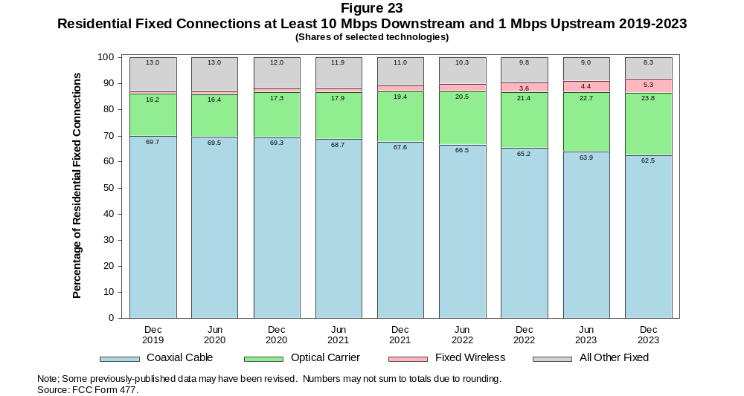

Figure 24
Fixed Connections at Least 25 Mbps Downstream and 3 Mbps Upstream by Technology 2019-2023
(in thousands)

 | 2019 | 2020 |  | 2021 |  | 2022 |  | 2023
Technology | Dec | Jun | Dec | Jun | Dec | Jun | Dec | Jun | Dec
Total | 90,490 | 97,000 | 101,630 | 106,790 | 110,630 | 113,048 | 116,189 | 118,842 | 121,840
Copper Wire¹ | * | * | * | 6,688 | 6,538 | 6,010 | 6,089 | 5,519 | 5,113
Coaxial Cable | 67,171 | 71,856 | 74,169 | 77,502 | 78,656 | 78,599 | 78,985 | 78,544 | 78,561
Optical Carrier | 15,866 | 17,091 | 18,840 | 20,171 | 22,459 | 24,282 | 25,761 | 27,894 | 29,858
Satellite | * | * | * | 1,328 | 1,353 | 1,552 | 1,685 | 1,734 | 1,889
Fixed Wireless | 468 | 571 | 805 | 1,105 | 1,620 | 2,605 | 3,669 | 5,152 | 6,419
Licensed | - | - | - | - | - | 1,797 | 2,801 | 4,359 | 5,621
Unlicensed | - | - | - | - | - | 808 | 868 | 793 | 798
¹ Power Line and Other are summarized with Copper Wire for confidentiality reasons. See Technical Notes at the end of the report for a description of FCC
Form 477 technology categories and other reporting requirements.
* = Data withheld for confidentiality reasons. # = Rounds to zero. - = Data was not collected.
Note: Some previously-published data may have been revised. Numbers may not sum to totals due to rounding.
Source: FCC Form 477.

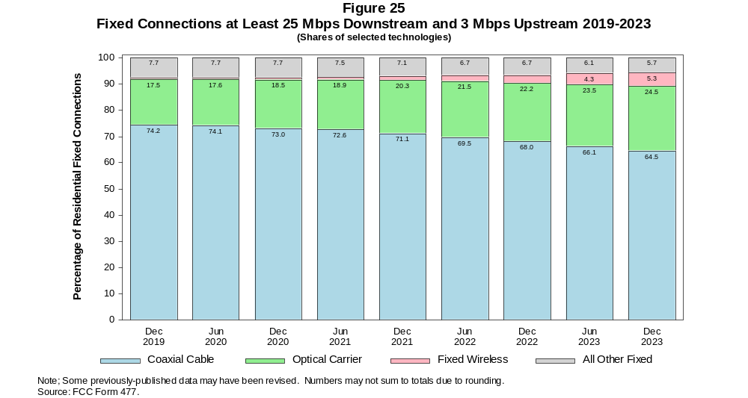

Figure 26
Residential Fixed Connections at Least 25 Mbps Downstream and 3 Mbps Upstream by Technology 2019-2023
(in thousands)

 | 2019 | 2020 |  | 2021 |  | 2022 |  | 2023
Technology | Dec | Jun | Dec | Jun | Dec | Jun | Dec | Jun | Dec
Total | 83,740 | 90,185 | 94,451 | 99,254 | 102,800 | 104,994 | 108,154 | 110,281 | 112,998
Copper Wire¹ | * | * | * | 6,068 | 5,930 | 5,511 | 5,541 | 5,104 | 4,736
Coaxial Cable | 62,231 | 67,017 | 69,098 | 72,268 | 73,262 | 73,214 | 73,556 | 73,102 | 73,006
Optical Carrier | 14,690 | 15,796 | 17,445 | 18,615 | 20,795 | 22,354 | 23,999 | 25,922 | 27,715
Satellite | * | * | * | 1,288 | 1,311 | 1,497 | 1,637 | 1,677 | 1,831
Fixed Wireless | 415 | 512 | 727 | 1,015 | 1,506 | 2,417 | 3,420 | 4,478 | 5,709
Licensed | - | - | - | - | - | 1,698 | 2,637 | 3,766 | 4,990
Unlicensed | - | - | - | - | - | 719 | 784 | 712 | 719
¹ Power Line and Other are summarized with Copper Wire for confidentiality reasons. See Technical Notes at the end of the report for a description of FCC
Form 477 technology categories and other reporting requirements.
* = Data withheld for confidentiality reasons. # = Rounds to zero. - = Data was not collected.
Note: Some previously-published data may have been revised. Numbers may not sum to totals due to rounding.
Source: FCC Form 477.

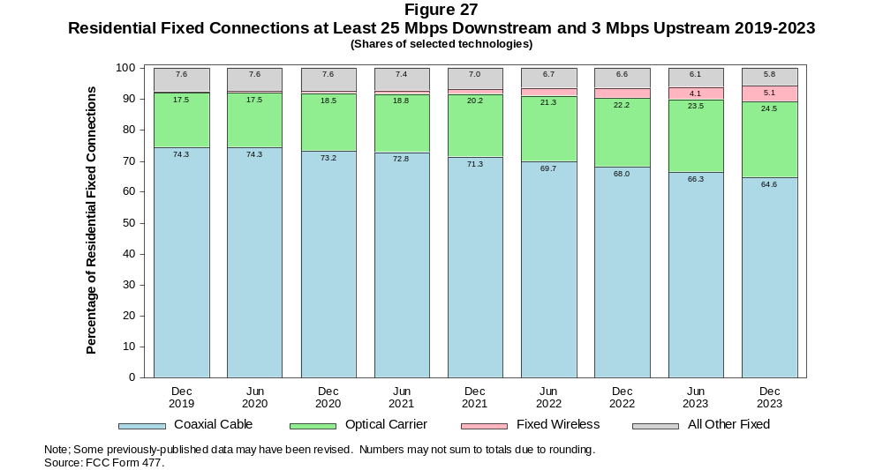

Figure 28
Fixed Connections at Least 100 Mbps Downstream and 20 Mbps Upstream by Technology 2019-2023
(in thousands)

 | 2019 | 2020 |  | 2021 |  | 2022 |  | 2023
Technology | Dec | Jun | Dec | Jun | Dec | Jun | Dec | Jun | Dec
Total | 25,621 | 29,570 | 34,493 | 38,563 | 43,352 | 52,836 | 58,395 | 62,079 | 69,269
Copper Wire¹ | * | * | * | * | * | * | * | * | *
Coaxial Cable | 13,088 | 15,496 | 18,420 | 20,924 | 23,298 | 29,953 | 33,391 | 34,407 | 38,477
Optical Carrier | 11,634 | 13,086 | 14,933 | 16,373 | 18,705 | 20,982 | 23,000 | 25,374 | 27,988
Satellite | * | * | * | * | * | * | * | * | *
Fixed Wireless | 119 | 116 | 143 | 180 | 239 | 500 | 880 | 1,392 | 1,941
Licensed | - | - | - | - | - | 302 | 675 | 1,209 | 1,729
Unlicensed | - | - | - | - | - | 198 | 205 | 184 | 212
¹ Power Line and Other are summarized with Copper Wire for confidentiality reasons. See Technical Notes at the end of the report for a description of FCC
Form 477 technology categories and other reporting requirements.
* = Data withheld for confidentiality reasons. # = Rounds to zero. - = Data was not collected.
Note: Some previously-published data may have been revised. Numbers may not sum to totals due to rounding.
Source: FCC Form 477.

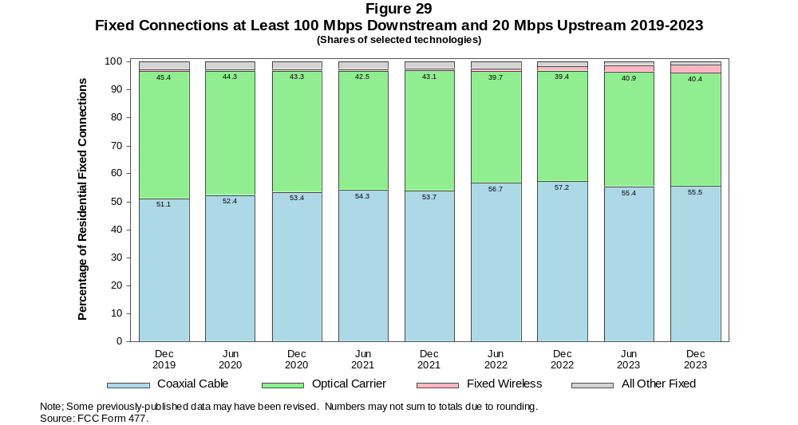

Figure 30
Residential Fixed Connections at Least 100 Mbps Downstream and 20 Mbps Upstream by Technology 2019-2023
(in thousands)

 | 2019 | 2020 |  | 2021 |  | 2022 |  | 2023
Technology | Dec | Jun | Dec | Jun | Dec | Jun | Dec | Jun | Dec
Total | 23,485 | 27,179 | 31,773 | 35,456 | 39,921 | 49,009 | 54,471 | 57,827 | 64,433
Copper Wire¹ | * | * | * | * | * | * | * | * | *
Coaxial Cable | 11,883 | 14,157 | 16,843 | 19,128 | 21,298 | 27,827 | 31,087 | 31,952 | 35,758
Optical Carrier | 10,952 | 12,303 | 14,055 | 15,329 | 17,537 | 19,508 | 21,672 | 23,804 | 26,165
Satellite | * | * | * | * | * | * | * | * | *
Fixed Wireless | 102 | 98 | 118 | 158 | 215 | 450 | 801 | 1,258 | 1,746
Licensed | - | - | - | - | - | 277 | 616 | 1,094 | 1,554
Unlicensed | - | - | - | - | - | 174 | 185 | 164 | 191
¹ Power Line and Other are summarized with Copper Wire for confidentiality reasons. See Technical Notes at the end of the report for a description of FCC
Form 477 technology categories and other reporting requirements.
* = Data withheld for confidentiality reasons. # = Rounds to zero. - = Data was not collected.
Note: Some previously-published data may have been revised. Numbers may not sum to totals due to rounding.
Source: FCC Form 477.

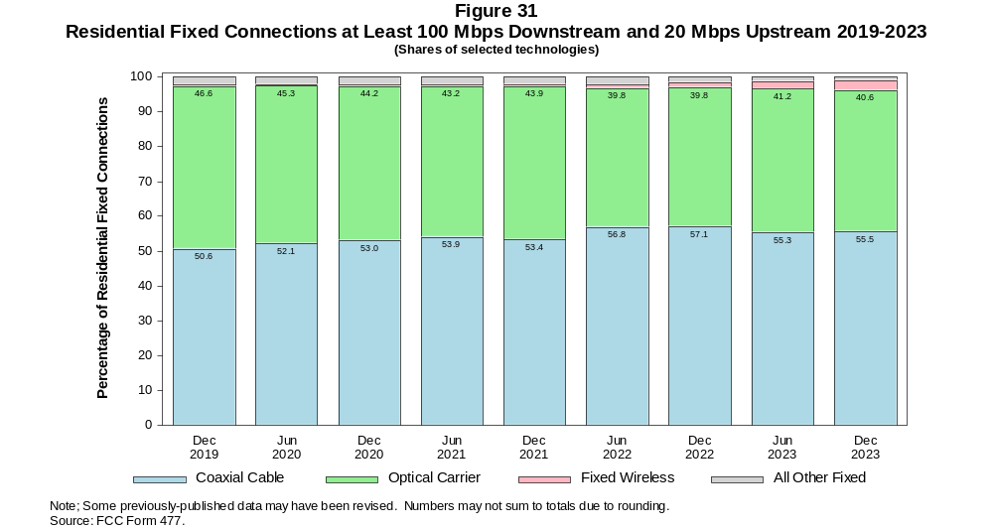

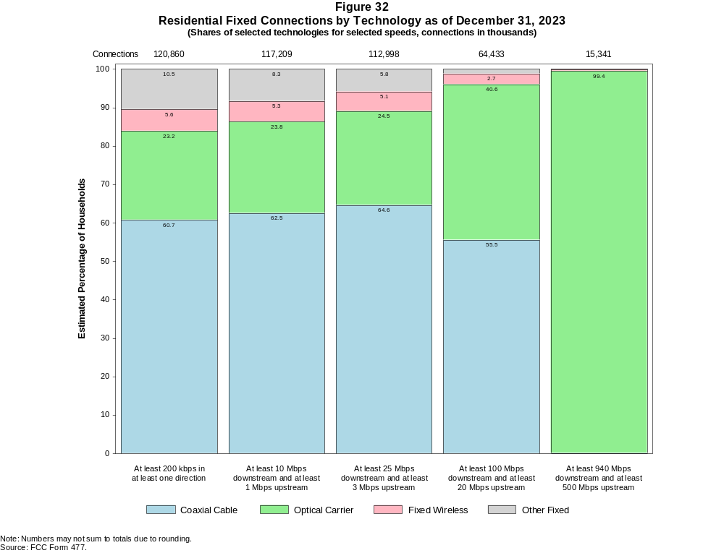

Figure 33
Fixed Connections by Downstream Speed Tier and Technology as of December 31, 2023
(in thousands)

 | Downstream Speed
Technology | Less than  10 Mbps | At least 10 Mbps  and less than  25 Mbps | At least 25 Mbps  and less than  100 Mbps | At least 100 Mbps  and less than  940 Mbps | At least  940 Mbps | Total
Total | 3,649 | 4,896 | 18,461 | 72,319 | 31,704 | 131,028
Copper Wire¹ | 2,751 | 3,569 | 4,517 | 1,006 | 7 | 11,850
Coaxial Cable | 111 | 352 | 6,900 | 56,520 | 15,194 | 79,078
Optical Carrier | 114 | 228 | 1,549 | 11,958 | 16,367 | 30,216
Satellite | * | * | * | * | 0 | 2,128
Fixed Wireless | * | * | * | * | 136 | 7,757

Percentages

Total | 2.8 | 3.7 | 14.1 | 55.2 | 24.2 | 100.0
Copper Wire¹ | 2.1 | 2.7 | 3.4 | 0.8 | 0.0 | 9.0
Coaxial Cable | 0.1 | 0.3 | 5.3 | 43.1 | 11.6 | 60.4
Optical Carrier | 0.1 | 0.2 | 1.2 | 9.1 | 12.5 | 23.1
Satellite | * | * | * | * | 0.0 | 1.6
Fixed Wireless | * | * | * | * | 0.1 | 5.9
¹ Other is summarized with Copper Wire for confidentiality reasons.
* = Data withheld for confidentiality reasons. # = Rounds to Zero.
Note: Numbers may not sum to totals due to rounding.
Source: FCC Form 477.

Figure 34
Residential Fixed Connections by Downstream Speed Tier and Technology as of December 31, 2023
(in thousands)

 | Downstream Speed
Technology | Less than  10 Mbps | At least 10 Mbps  and less than  25 Mbps | At least 25 Mbps  and less than  100 Mbps | At least 100 Mbps  and less than  940 Mbps | At least  940 Mbps | Total
Total | 3,151 | 4,264 | 16,170 | 66,924 | 30,349 | 120,860
Copper Wire¹ | 2,375 | 3,151 | 4,175 | 929 | 7 | 10,636
Coaxial Cable | 83 | 247 | 5,940 | 52,384 | 14,732 | 73,386
Optical Carrier | 95 | 176 | 1,246 | 11,003 | 15,480 | 28,000
Satellite | * | * | 870 | * | 0 | 2,037
Fixed Wireless | * | * | 3,940 | * | 131 | 6,800

Percentages

Total | 2.6 | 3.5 | 13.4 | 55.4 | 25.1 | 100.0
Copper Wire¹ | 2.0 | 2.6 | 3.5 | 0.8 | 0.0 | 8.8
Coaxial Cable | 0.1 | 0.2 | 4.9 | 43.3 | 12.2 | 60.7
Optical Carrier | 0.1 | 0.1 | 1.0 | 9.1 | 12.8 | 23.2
Satellite | * | * | 0.7 | * | 0.0 | 1.7
Fixed Wireless | * | * | 3.3 | * | 0.1 | 5.6
¹ Other is summarized with Copper Wire for confidentiality reasons.
* = Data withheld for confidentiality reasons. # = Rounds to Zero.
Note: Numbers may not sum to totals due to rounding.
Source: FCC Form 477.

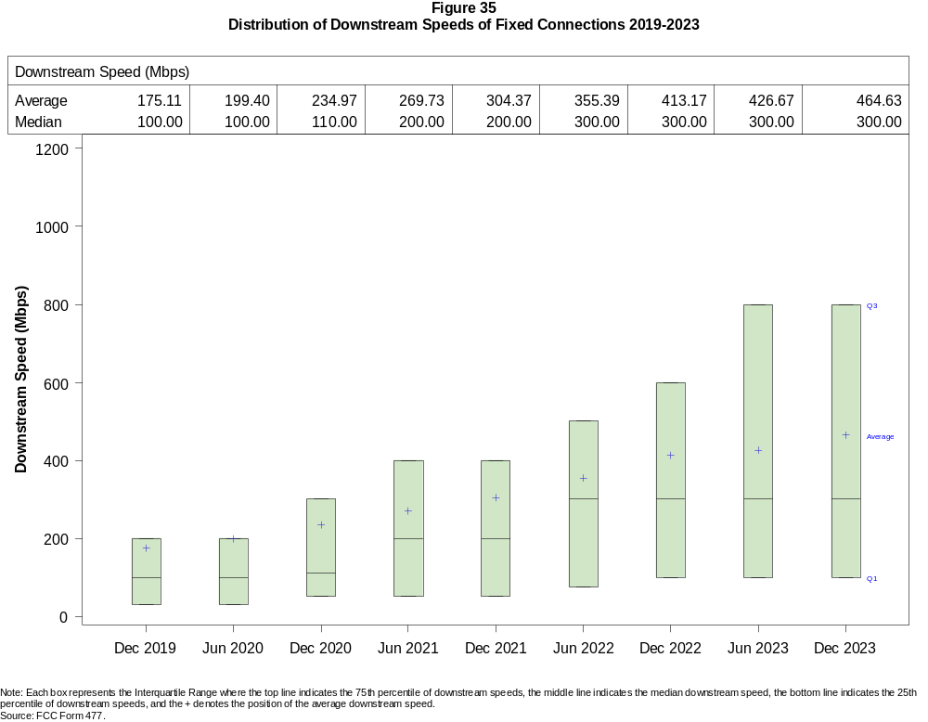

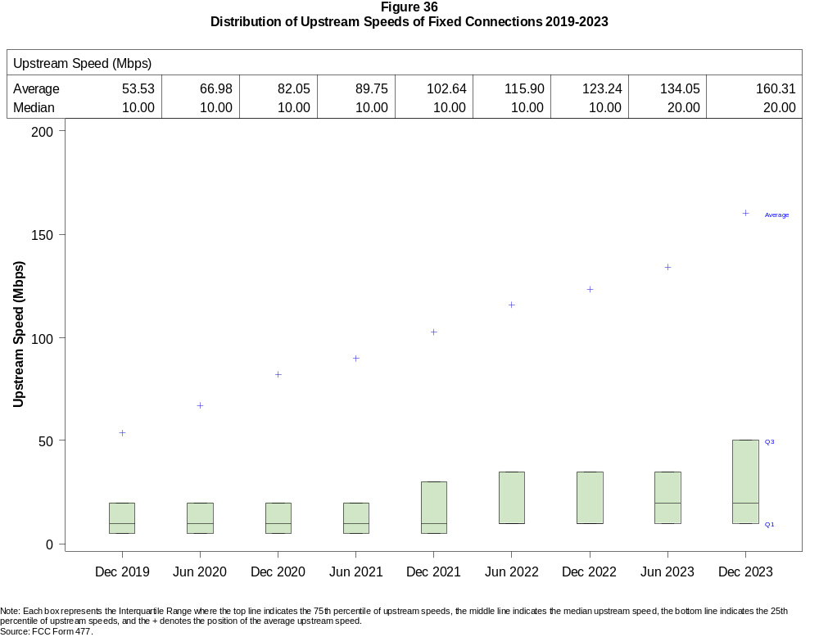

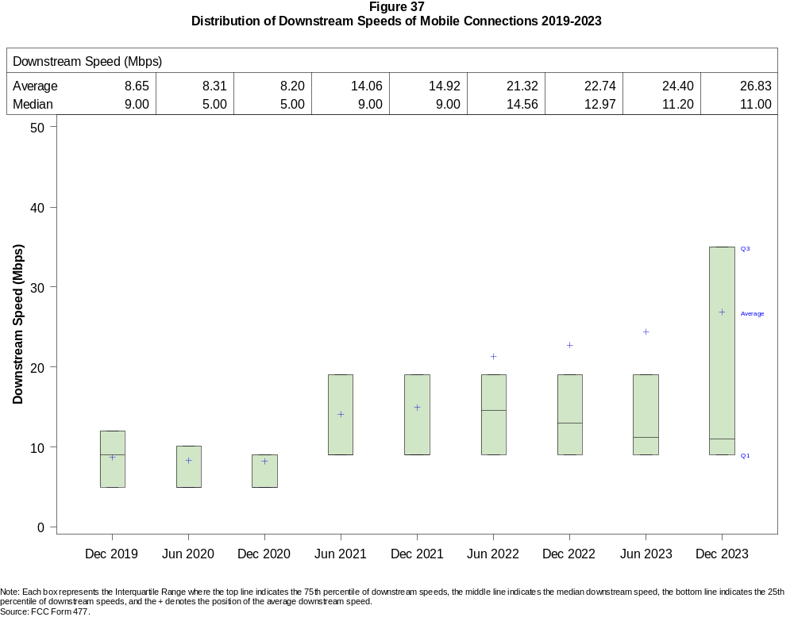

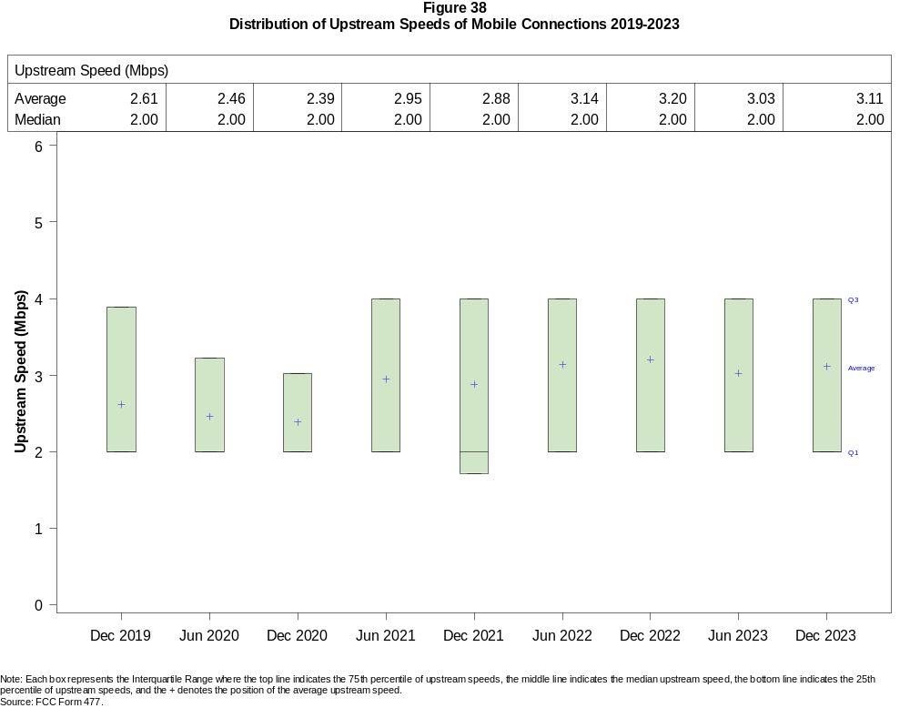

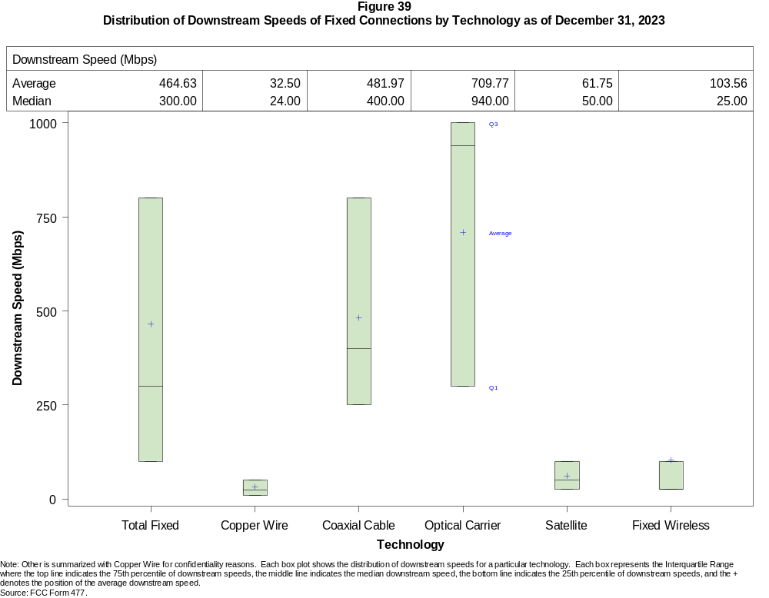

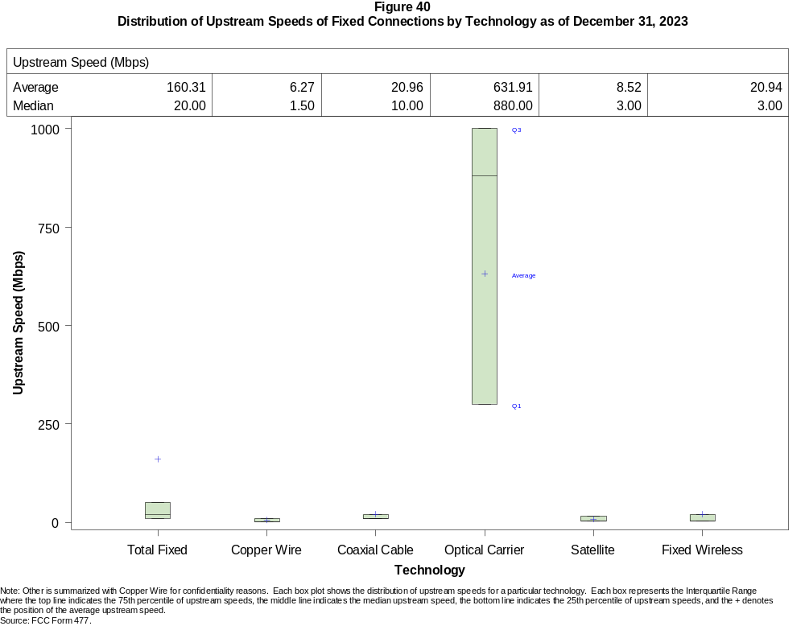

Figure 41
Nationwide Number of Providers of Connections over 200 kbps in at Least One Direction
by Technology 2019-2023

 | 2019 | 2020 |  | 2021 |  | 2022 |  | 2023
Technology | Dec | Jun | Dec | Jun | Dec | Jun | Dec | Jun | Dec
Total | 2,248 | 2,281 | 2,382 | 2,392 | 2,384 | 2,252 | 2,282 | 2,235 | 2,173
Mobile | 67 | 64 | 64 | 63 | 62 | 58 | 57 | 56 | 53
Fixed | 2,230 | 2,266 | 2,371 | 2,378 | 2,371 | 2,243 | 2,273 | 2,226 | 2,166
Copper Wire¹ | 803 | 797 | 773 | 755 | 743 | 594 | 570 | 546 | 522
Coaxial Cable | 373 | 365 | 368 | 362 | 352 | 311 | 305 | 309 | 304
Optical Carrier | 1,331 | 1,380 | 1,442 | 1,477 | 1,505 | 1,475 | 1,519 | 1,539 | 1,548
Satellite | 5 | 5 | 6 | 6 | 5 | 4 | 4 | 4 | 4
Fixed Wireless | 1,281 | 1,313 | 1,397 | 1,383 | 1,359 | 1,237 | 1,247 | 1,190 | 1,134
Licensed | - | - | - | - | - | 299 | 357 | 375 | 389
Unlicensed | - | - | - | - | - | 1,133 | 1,135 | 1,076 | 1,027
¹ Prior to June 2022, Power Line is summarized with Other for confidentiality reasons.
* = 1 - 3 providers. - = Data not collected.
Note: Multiple FCC Form 477 filers within a holding company structure count as one provider. Some previously-published data may have been revised.
Source: FCC Form 477.

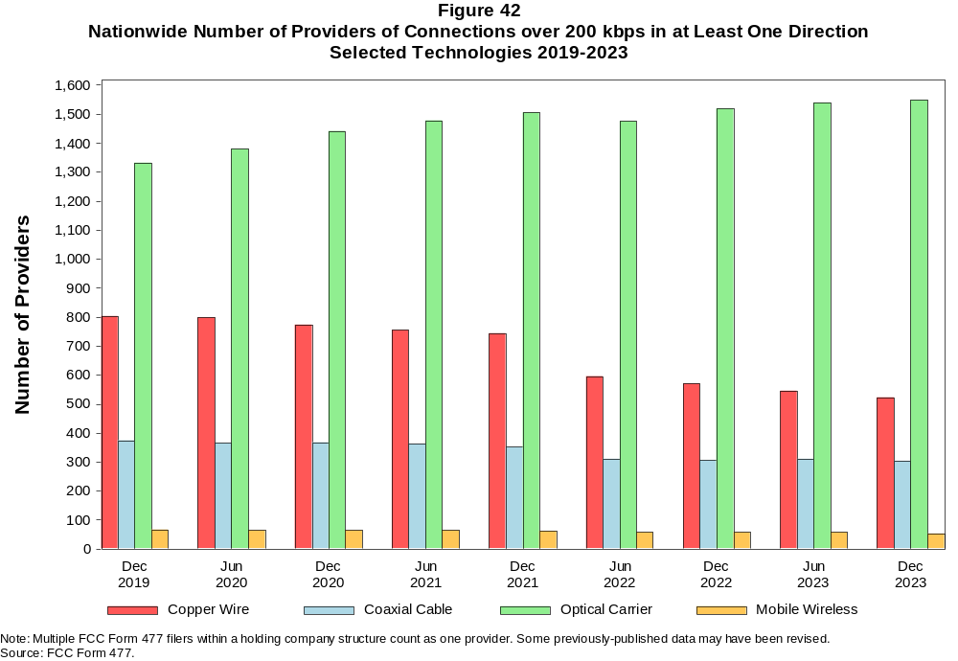

Figure 43
Residential Fixed Connections and Households by State as of December 31, 2023
(Connections and households in thousands)

 |  | At least 200 kbps in  at least One Direction |  | At least 10 Mbps Down  and 1 Mbps Up |  | At least 25 Mbps Down  and 3 Mbps Up |  | At least 100 Mbps Down  and 20 Mbps Up |  | At least 940 Mbps Down  and 500 Mbps Up
State | Households | Connections | Subscribership  Ratio | Connections | Subscribership  Ratio | Connections | Subscribership  Ratio | Connections | Subscribership  Ratio | Connections | Subscribership  Ratio
Alabama | 1,933 | 1,730 | 0.89 | 1,640 | 0.85 | 1,561 | 0.81 | 834 | 0.43 | 204 | 0.11
Alaska | 264 | 246 | 0.93 | 239 | 0.90 | 207 | 0.78 | * | * | * | *
American Samoa | 10 | * | * | * | * | * | * | 0 | 0.00 | 0 | 0.00
Arizona | 2,739 | 2,626 | 0.96 | 2,542 | 0.93 | 2,420 | 0.88 | 1,357 | 0.50 | 121 | 0.04
Arkansas | 1,172 | 1,034 | 0.88 | 969 | 0.83 | 898 | 0.77 | 547 | 0.47 | 104 | 0.09
California | 13,316 | 13,063 | 0.98 | 12,791 | 0.96 | 12,384 | 0.93 | 6,710 | 0.50 | 951 | 0.07
Colorado | 2,278 | 2,333 | 1.02 | 2,253 | 0.99 | 2,154 | 0.95 | 1,062 | 0.47 | 184 | 0.08
Connecticut | 1,410 | 1,351 | 0.96 | 1,334 | 0.95 | 1,301 | 0.92 | 871 | 0.62 | 125 | 0.09
Delaware | 389 | 416 | 1.07 | 412 | 1.06 | 411 | 1.06 | 283 | 0.73 | * | *
District of Columbia | 316 | 294 | 0.93 | 291 | 0.92 | 290 | 0.92 | 195 | 0.62 | * | *
Florida | 8,353 | 8,808 | 1.05 | 8,636 | 1.03 | 8,455 | 1.01 | 4,556 | 0.55 | 766 | 0.09
Georgia | 3,946 | 3,819 | 0.97 | 3,694 | 0.94 | 3,553 | 0.90 | 2,148 | 0.54 | 535 | 0.14
Guam | 42 | 35 | 0.84 | 34 | 0.80 | 29 | 0.70 | * | * | 0 | 0.00
Hawaii | 484 | 502 | 1.04 | 495 | 1.02 | 483 | 1.00 | * | * | * | *
Idaho | 675 | 648 | 0.96 | 597 | 0.88 | 523 | 0.77 | 339 | 0.50 | 44 | 0.07
Illinois | 4,969 | 4,379 | 0.88 | 4,227 | 0.85 | 4,029 | 0.81 | 2,021 | 0.41 | 222 | 0.04
Indiana | 2,654 | 2,431 | 0.92 | 2,328 | 0.88 | 2,212 | 0.83 | 1,202 | 0.45 | 238 | 0.09
Iowa | 1,290 | 1,163 | 0.90 | 1,102 | 0.85 | 1,017 | 0.79 | 722 | 0.56 | 121 | 0.09
Kansas | 1,149 | 1,032 | 0.90 | 997 | 0.87 | 946 | 0.82 | 600 | 0.52 | 185 | 0.16
Kentucky | 1,769 | 1,648 | 0.93 | 1,568 | 0.89 | 1,492 | 0.84 | 836 | 0.47 | 163 | 0.09
Louisiana | 1,765 | 1,534 | 0.87 | 1,458 | 0.83 | 1,381 | 0.78 | 666 | 0.38 | 139 | 0.08
Maine | 580 | 582 | 1.00 | 555 | 0.96 | 510 | 0.88 | 145 | 0.25 | 5 | 0.01
Maryland | 2,318 | 2,227 | 0.96 | 2,202 | 0.95 | 2,188 | 0.94 | 1,547 | 0.67 | * | *
Massachusetts | 2,741 | 2,672 | 0.97 | 2,641 | 0.96 | 2,635 | 0.96 | 1,590 | 0.58 | 548 | 0.20
Michigan | 4,009 | 3,717 | 0.93 | 3,598 | 0.90 | 3,466 | 0.86 | 1,446 | 0.36 | 119 | 0.03
Minnesota | 2,256 | 2,102 | 0.93 | 2,026 | 0.90 | 1,910 | 0.85 | 955 | 0.42 | 111 | 0.05
Mississippi | 1,121 | 961 | 0.86 | 895 | 0.80 | 811 | 0.72 | 563 | 0.50 | 201 | 0.18
Missouri | 2,458 | 2,200 | 0.90 | 2,086 | 0.85 | 1,936 | 0.79 | 1,129 | 0.46 | 286 | 0.12
Montana | 444 | 426 | 0.96 | 401 | 0.90 | 362 | 0.82 | 118 | 0.27 | 11 | 0.03
Nebraska | 776 | 710 | 0.91 | 685 | 0.88 | 652 | 0.84 | 413 | 0.53 | 57 | 0.07

Figure 43 - Continued
Residential Fixed Connections and Households by State as of December 31, 2023
(Connections and households in thousands)

 |  | At least 200 kbps in  at least One Direction |  | At least 10 Mbps Down  and 1 Mbps Up |  | At least 25 Mbps Down  and 3 Mbps Up |  | At least 100 Mbps Down  and 20 Mbps Up |  | At least 940 Mbps Down  and 500 Mbps Up
State | Households | Connections | Subscribership  Ratio | Connections | Subscribership  Ratio | Connections | Subscribership  Ratio | Connections | Subscribership  Ratio | Connections | Subscribership  Ratio
Nevada | 1,164 | 1,132 | 0.97 | 1,103 | 0.95 | 1,066 | 0.92 | 645 | 0.55 | 74 | 0.06
New Hampshire | 545 | 562 | 1.03 | 549 | 1.01 | 533 | 0.98 | 295 | 0.54 | 6 | 0.01
New Jersey | 3,438 | 3,320 | 0.97 | 3,286 | 0.96 | 3,280 | 0.95 | 2,524 | 0.73 | * | *
New Mexico | 813 | 732 | 0.90 | 683 | 0.84 | 622 | 0.77 | 252 | 0.31 | 28 | 0.03
New York | 7,605 | 6,731 | 0.89 | 6,674 | 0.88 | 6,589 | 0.87 | 4,208 | 0.55 | 1,608 | 0.21
North Carolina | 4,105 | 4,301 | 1.05 | 4,104 | 1.00 | 3,985 | 0.97 | 2,136 | 0.52 | 451 | 0.11
North Dakota | 320 | 298 | 0.93 | 295 | 0.92 | 290 | 0.91 | 269 | 0.84 | 16 | 0.05
Northern Mariana Isl | 16 | * | * | * | * | * | * | 0 | 0.00 | 0 | 0.00
Ohio | 4,789 | 4,452 | 0.93 | 4,309 | 0.90 | 4,125 | 0.86 | 1,996 | 0.42 | 222 | 0.05
Oklahoma | 1,523 | 1,337 | 0.88 | 1,273 | 0.84 | 1,180 | 0.78 | 738 | 0.48 | 194 | 0.13
Oregon | 1,681 | 1,604 | 0.95 | 1,549 | 0.92 | 1,488 | 0.89 | 708 | 0.42 | 104 | 0.06
Pennsylvania | 5,194 | 4,775 | 0.92 | 4,607 | 0.89 | 4,548 | 0.88 | 2,855 | 0.55 | * | *
Puerto Rico | 1,220 | 744 | 0.61 | 688 | 0.56 | 588 | 0.48 | 218 | 0.18 | 12 | 0.01
Rhode Island | 432 | 406 | 0.94 | 404 | 0.94 | 404 | 0.93 | 286 | 0.66 | * | *
South Carolina | 2,023 | 2,077 | 1.03 | 2,022 | 1.00 | 1,946 | 0.96 | 1,101 | 0.54 | 148 | 0.07
South Dakota | 351 | 331 | 0.94 | 327 | 0.93 | 321 | 0.91 | 269 | 0.77 | 22 | 0.06
Tennessee | 2,714 | 2,576 | 0.95 | 2,506 | 0.92 | 2,433 | 0.90 | 1,434 | 0.53 | 427 | 0.16
Texas | 10,491 | 10,318 | 0.98 | 10,075 | 0.96 | 9,726 | 0.93 | 6,034 | 0.58 | 1,579 | 0.15
Utah | 1,063 | 1,071 | 1.01 | 1,039 | 0.98 | 1,004 | 0.94 | 607 | 0.57 | 210 | 0.20
Vermont | 266 | 270 | 1.01 | 253 | 0.95 | 225 | 0.85 | 104 | 0.39 | 16 | 0.06
Virgin Islands | 43 | 27 | 0.63 | 25 | 0.57 | 25 | 0.57 | * | * | 0 | 0.00
Virginia | 3,290 | 3,043 | 0.93 | 2,945 | 0.90 | 2,902 | 0.88 | 1,953 | 0.59 | 993 | 0.30
Washington | 2,979 | 2,960 | 0.99 | 2,858 | 0.96 | 2,755 | 0.92 | 1,375 | 0.46 | 217 | 0.07
West Virginia | 716 | 604 | 0.84 | 558 | 0.78 | 511 | 0.71 | 299 | 0.42 | 29 | 0.04
Wisconsin | 2,425 | 2,261 | 0.93 | 2,154 | 0.89 | 2,017 | 0.83 | 808 | 0.33 | 77 | 0.03
Wyoming | 234 | 225 | 0.96 | 214 | 0.92 | 203 | 0.87 | 71 | 0.30 | 10 | 0.04
Total | 127,067 | 120,860 | 0.95 | 117,209 | 0.92 | 112,998 | 0.89 | 64,433 | 0.51 | 15,341 | 0.12
# = Rounds to Zero; * = Data withheld for confidentiality reasons.
Note: Numbers may not sum to totals due to rounding.
Sources: FCC Form 477 (Connections); 2018-2022 ACS 5-year estimates; Census 2010.

Figure 44
Connections by Type of End User by State as of December 31, 2023
(Connections in thousands)

 | Connections |  | Percentages
State | Residential | Business | Residential | Business | Total
Alabama | 6,693 | 1,131 | 85.5 | 14.5 | 7,824
Alaska | 940 | 158 | 85.6 | 14.4 | 1,098
American Samoa | * | * | * | * | *
Arizona | 9,899 | 1,512 | 86.8 | 13.2 | 11,411
Arkansas | 4,003 | 558 | 87.8 | 12.2 | 4,560
California | 55,049 | 10,396 | 84.1 | 15.9 | 65,444
Colorado | 7,859 | 1,636 | 82.8 | 17.2 | 9,494
Connecticut | 5,097 | 970 | 84.0 | 16.0 | 6,066
Delaware | 1,451 | 256 | 85.0 | 15.0 | 1,708
District of Columbia | 1,231 | 704 | 63.6 | 36.4 | 1,935
Florida | 32,897 | 5,686 | 85.3 | 14.7 | 38,583
Georgia | 15,047 | 2,708 | 84.7 | 15.3 | 17,755
Guam | 169 | 38 | 81.9 | 18.1 | 207
Hawaii | 1,950 | 399 | 83.0 | 17.0 | 2,349
Idaho | 2,395 | 374 | 86.5 | 13.5 | 2,769
Illinois | 17,281 | 3,322 | 83.9 | 16.1 | 20,603
Indiana | 8,776 | 1,427 | 86.0 | 14.0 | 10,203
Iowa | 4,131 | 664 | 86.1 | 13.9 | 4,795
Kansas | 3,846 | 619 | 86.1 | 13.9 | 4,464
Kentucky | 5,847 | 1,217 | 82.8 | 17.2 | 7,064
Louisiana | 6,405 | 954 | 87.0 | 13.0 | 7,359
Maine | 1,761 | 398 | 81.6 | 18.4 | 2,159
Maryland | 8,666 | 1,483 | 85.4 | 14.6 | 10,149
Massachusetts | 9,608 | 1,947 | 83.1 | 16.9 | 11,555
Michigan | 13,248 | 2,504 | 84.1 | 15.9 | 15,752
Minnesota | 7,446 | 1,392 | 84.2 | 15.8 | 8,838
Mississippi | 4,031 | 501 | 88.9 | 11.1 | 4,532
Missouri | 8,041 | 1,484 | 84.4 | 15.6 | 9,526
Montana | 1,402 | 279 | 83.4 | 16.6 | 1,682
Nebraska | 2,516 | 542 | 82.3 | 17.7 | 3,058
Nevada | 4,478 | 632 | 87.6 | 12.4 | 5,110
New Hampshire | 1,814 | 435 | 80.7 | 19.3 | 2,249
New Jersey | 13,322 | 2,504 | 84.2 | 15.8 | 15,826
New Mexico | 2,833 | 438 | 86.6 | 13.4 | 3,271
New York | 28,079 | 5,350 | 84.0 | 16.0 | 33,429
North Carolina | 14,286 | 2,815 | 83.5 | 16.5 | 17,102
North Dakota | 1,039 | 183 | 85.0 | 15.0 | 1,223
Northern Mariana Isl | * | * | * | * | *
Ohio | 15,547 | 3,102 | 83.4 | 16.6 | 18,649
Oklahoma | 5,281 | 822 | 86.5 | 13.5 | 6,103
Oregon | 5,555 | 1,113 | 83.3 | 16.7 | 6,668
Pennsylvania | 17,597 | 3,189 | 84.7 | 15.3 | 20,786
Puerto Rico | 4,071 | 495 | 89.2 | 10.8 | 4,566
Rhode Island | 1,507 | 291 | 83.8 | 16.2 | 1,798
South Carolina | 6,975 | 1,201 | 85.3 | 14.7 | 8,175
South Dakota | 1,163 | 168 | 87.4 | 12.6 | 1,331
Tennessee | 9,472 | 1,638 | 85.3 | 14.7 | 11,110
Texas | 42,431 | 7,013 | 85.8 | 14.2 | 49,443
Utah | 4,043 | 880 | 82.1 | 17.9 | 4,924
Vermont | 790 | 217 | 78.5 | 21.5 | 1,006
Virgin Islands | 139 | 9 | 94.0 | 6.0 | 148
Virginia | 11,716 | 2,146 | 84.5 | 15.5 | 13,861
Washington | 10,393 | 2,063 | 83.4 | 16.6 | 12,456
West Virginia | 2,220 | 288 | 88.5 | 11.5 | 2,508
Wisconsin | 7,122 | 1,461 | 83.0 | 17.0 | 8,583
Wyoming | 779 | 149 | 83.9 | 16.1 | 929
Total | 460,431 | 83,881 | 84.6 | 15.4 | 544,312
* = Data withheld for confidentiality reasons. # = Rounds to Zero.
Note: Numbers may not sum to totals due to rounding.
Source: FCC Form 477.

Figure 45
Connections by Technology by State as of December 31, 2023
(Connections in thousands)

State | Copper  Wire¹ | Coaxial  Cable | Optical  Carrier | Other  Fixed² | Mobile  Wireless | Total
Alabama | 257 | 968 | 480 | 173 | 5,946 | 7,824
Alaska | 61 | * | 19 | * | 814 | 1,098
American Samoa | 0 | * | * | * | * | *
Arizona | 384 | 1,804 | 265 | 348 | 8,611 | 11,411
Arkansas | 200 | 461 | 353 | 108 | 3,439 | 4,560
California | 1,473 | 9,458 | 2,178 | 1,056 | 51,281 | 65,444
Colorado | * | 1,667 | 330 | * | 6,990 | 9,494
Connecticut | * | 1,095 | 261 | * | 4,602 | 6,066
Delaware | * | * | * | 20 | 1,264 | 1,708
District of Columbia | * | * | * | 19 | 1,614 | 1,935
Florida | 731 | 6,169 | 2,115 | 503 | 29,066 | 38,583
Georgia | 529 | 2,260 | 1,112 | 254 | 13,600 | 17,755
Guam | * | * | 2 | 2 | * | 207
Hawaii | * | * | * | 16 | 1,794 | 2,349
Idaho | 139 | 300 | 116 | 146 | 2,068 | 2,769
Illinois | 622 | 3,121 | 569 | 425 | 15,866 | 20,603
Indiana | 311 | 1,398 | 671 | 239 | 7,584 | 10,203
Iowa | 175 | 433 | 505 | 151 | 3,532 | 4,795
Kansas | 109 | 490 | 402 | 121 | 3,342 | 4,464
Kentucky | 222 | 1,004 | 618 | 114 | 5,105 | 7,064
Louisiana | 231 | 908 | 380 | 147 | 5,692 | 7,359
Maine | 69 | 489 | 76 | 38 | 1,487 | 2,159
Maryland | * | 1,328 | * | 112 | 7,766 | 10,149
Massachusetts | * | 2,148 | 610 | * | 8,674 | 11,555
Michigan | 443 | 2,836 | 384 | 338 | 11,751 | 15,752
Minnesota | 304 | 1,354 | 408 | 206 | 6,566 | 8,838
Mississippi | 219 | 367 | 384 | 85 | 3,476 | 4,532
Missouri | 353 | 1,095 | 684 | 262 | 7,131 | 9,526
Montana | 65 | * | 67 | * | 1,208 | 1,682
Nebraska | 81 | 371 | 242 | 80 | 2,284 | 3,058

Figure 45 - Continued
Connections by Technology by State as of December 31, 2023
(Connections in thousands)

State | Copper  Wire¹ | Coaxial  Cable | Optical  Carrier | Other  Fixed² | Mobile  Wireless | Total
Nevada | 100 | 831 | 159 | 125 | 3,895 | 5,110
New Hampshire | * | * | 86 | 21 | 1,583 | 2,249
New Jersey | 40 | 2,123 | 1,308 | 133 | 12,223 | 15,826
New Mexico | 157 | 463 | 78 | 91 | 2,483 | 3,271
New York | 93 | 4,866 | 2,078 | 278 | 26,113 | 33,429
North Carolina | 404 | 2,883 | 1,056 | 283 | 12,476 | 17,102
North Dakota | 11 | 170 | 145 | 14 | 883 | 1,223
Northern Mariana Isl | * | * | * | * | * | *
Ohio | 479 | 3,135 | 830 | 361 | 13,844 | 18,649
Oklahoma | 208 | 622 | 428 | 194 | 4,651 | 6,103
Oregon | 134 | 1,153 | 294 | 155 | 4,932 | 6,668
Pennsylvania | 230 | 3,385 | 1,229 | 286 | 15,656 | 20,786
Puerto Rico | * | * | 205 | 83 | * | 4,566
Rhode Island | * | * | * | 14 | 1,363 | 1,798
South Carolina | 213 | 1,291 | 597 | 145 | 5,931 | 8,175
South Dakota | 22 | 198 | 125 | 21 | 966 | 1,331
Tennessee | 238 | 1,422 | 963 | 184 | 8,303 | 11,110
Texas | 955 | 5,680 | 3,461 | 1,069 | 38,278 | 49,443
Utah | 93 | 589 | 338 | 128 | 3,777 | 4,924
Vermont | 50 | 190 | 60 | 17 | 689 | 1,006
Virgin Islands | 0 | * | 0 | * | * | 148
Virginia | 126 | 1,743 | 1,170 | 232 | 10,590 | 13,861
Washington | 260 | 2,241 | 387 | 271 | 9,298 | 12,456
West Virginia | * | 433 | 66 | * | 1,853 | 2,508
Wisconsin | 348 | * | 450 | * | 6,127 | 8,583
Wyoming | 31 | 133 | 30 | 58 | 678 | 929
Total | 11,850 | 79,078 | 30,216 | 9,885 | 413,283 | 544,312
* = Data withheld for confidentiality reasons. # = Rounds to Zero.
¹ Other is summarized with Copper Wire for confidentiality reasons.
² Fixed Wireless and Satellite are summarized as Other Fixed for confidentiality reasons.
Note: Numbers may not sum to totals due to rounding.
Source: FCC Form 477.

Figure 46
Percentage of Fixed Connections by Downstream Speed by State as of December 31, 2023

 | Over 200 kbps Upstream and
State | % over 200 kbps  Downstream | % at least 10 Mbps  Downstream | % at least 25 Mbps  Downstream | % at least 100 Mbps  Downstream | % at least 940 Mbps  Downstream
Alabama | 99.7 | 95.6 | 90.4 | 74.0 | 18.3
Alaska | 99.9 | 95.9 | 83.8 | * | *
American Samoa | * | * | * | * | *
Arizona | 99.5 | 97.3 | 92.6 | 78.8 | 17.5
Arkansas | 99.6 | 94.8 | 87.1 | 69.1 | 17.6
California | 99.8 | 97.7 | 94.3 | 80.6 | 20.2
Colorado | 99.7 | 97.1 | 92.5 | 77.2 | 29.8
Connecticut | 99.9 | 98.6 | 96.4 | 88.1 | 26.5
Delaware | 99.9 | 98.8 | 98.5 | 89.3 | 50.7
District of Columbia | 99.9 | 98.4 | 97.9 | 87.4 | 43.2
Florida | 99.7 | 98.4 | 96.1 | 81.0 | 19.4
Georgia | 99.6 | 96.6 | 93.0 | 75.6 | 26.6
Guam | 100.0 | 90.4 | 82.1 | 12.7 | 0.0
Hawaii | 99.8 | 97.7 | 95.2 | 85.7 | *
Idaho | 98.8 | 93.5 | 82.1 | 62.9 | 15.3
Illinois | 99.9 | 96.4 | 92.0 | 69.6 | 20.7
Indiana | 99.5 | 96.2 | 91.1 | 71.0 | 20.1
Iowa | 99.6 | 95.7 | 88.3 | 67.3 | 24.8
Kansas | 99.7 | 97.1 | 91.6 | 75.6 | 25.8
Kentucky | 99.8 | 95.7 | 90.1 | 75.7 | 13.5
Louisiana | 99.6 | 95.5 | 90.0 | 74.8 | 17.9
Maine | 99.7 | 94.6 | 88.6 | 77.0 | 9.5
Maryland | 99.9 | 98.6 | 97.9 | 87.5 | 52.8
Massachusetts | 99.6 | 98.7 | 98.4 | 90.6 | 40.1
Michigan | 99.9 | 96.9 | 93.2 | 74.2 | 15.5
Minnesota | 99.6 | 97.1 | 91.7 | 72.3 | 22.5
Mississippi | 99.6 | 93.1 | 84.4 | 66.1 | 31.0
Missouri | 99.6 | 96.2 | 88.6 | 71.9 | 19.8
Montana | 99.5 | 95.6 | 86.1 | 70.5 | 5.4
Nebraska | 99.9 | 96.8 | 92.1 | 78.6 | 14.0

Figure 46 - Continued
Percentage of Fixed Connections by Downstream Speed by State as of December 31, 2023

 | Over 200 kbps Upstream and
State | % over 200 kbps  Downstream | % at least 10 Mbps  Downstream | % at least 25 Mbps  Downstream | % at least 100 Mbps  Downstream | % at least 940 Mbps  Downstream
Nevada | 99.7 | 97.8 | 94.8 | 83.7 | 18.9
New Hampshire | 99.4 | 96.8 | 94.6 | 85.0 | 26.8
New Jersey | 99.6 | 99.0 | 98.6 | 92.2 | 49.5
New Mexico | 99.3 | 94.9 | 86.1 | 62.7 | 17.9
New York | 99.9 | 99.0 | 97.7 | 91.9 | 29.3
North Carolina | 99.6 | 96.6 | 92.8 | 82.6 | 15.5
North Dakota | 99.8 | 99.0 | 97.0 | 89.1 | 51.0
Northern Mariana Isl | * | * | * | * | *
Ohio | 99.7 | 97.0 | 92.7 | 79.2 | 12.1
Oklahoma | 99.7 | 95.1 | 88.0 | 72.5 | 23.7
Oregon | 99.6 | 97.3 | 93.1 | 77.9 | 22.7
Pennsylvania | 99.5 | 96.9 | 95.2 | 83.5 | 37.4
Puerto Rico | 100.0 | 92.0 | 80.4 | 34.3 | 3.0
Rhode Island | 99.7 | 99.3 | 99.2 | 95.7 | 53.6
South Carolina | 99.8 | 97.5 | 93.6 | 80.8 | 13.0
South Dakota | 99.8 | 98.8 | 97.0 | 84.3 | 50.9
Tennessee | 99.8 | 97.4 | 94.3 | 78.3 | 25.2
Texas | 99.8 | 97.7 | 94.1 | 79.5 | 24.0
Utah | 99.7 | 97.3 | 93.8 | 78.3 | 38.5
Vermont | 99.3 | 93.0 | 85.8 | 70.9 | 22.8
Virgin Islands | 100.0 | 91.5 | 88.3 | * | *
Virginia | 99.5 | 97.2 | 95.2 | 85.9 | 43.8
Washington | 99.5 | 97.2 | 93.2 | 79.4 | 29.5
West Virginia | 99.5 | 92.5 | 85.1 | 72.0 | 20.0
Wisconsin | 99.7 | 96.4 | 89.7 | 76.2 | 7.1
Wyoming | 99.6 | 96.1 | 90.6 | 68.6 | 8.2
Total | 99.7 | 97.2 | 93.5 | 79.4 | 24.2
* = Data withheld for confidentiality reasons.
Source: FCC Form 477.

Figure 47
Providers of Connections by Technology by State as of December 31, 2023
(Connections over 200 kbps in at least one direction)

State | Copper  Wire¹ | Coaxial  Cable | Optical  Carrier | Satellite | Fixed  Wireless | Mobile  Wireless | Unduplicated  Total
Alabama | 21 | 14 | 47 | * | 18 | 7 | 74
Alaska | 13 | * | 19 | * | 14 | 11 | 32
American Samoa | 0 | * | * | 0 | * | * | *
Arizona | 19 | 13 | 43 | * | 46 | 7 | 84
Arkansas | 19 | 13 | 51 | * | 31 | 5 | 81
California | 27 | 27 | 74 | * | 115 | 6 | 179
Colorado | 25 | 11 | 81 | * | 67 | 10 | 124
Connecticut | 4 | 5 | 14 | * | * | 5 | 21
Delaware | * | 4 | 13 | * | 5 | 4 | 21
District of Columbia | 5 | * | 15 | * | 8 | 5 | 25
Florida | 15 | 15 | 59 | * | 33 | 5 | 88
Georgia | 23 | 24 | 79 | * | 24 | 6 | 103
Guam | * | * | 5 | * | * | * | 6
Hawaii | 5 | * | 9 | * | 4 | 4 | 17
Idaho | 18 | 14 | 37 | * | 41 | 8 | 66
Illinois | 37 | 15 | 92 | * | 70 | 6 | 141
Indiana | 27 | 9 | 81 | * | 58 | 5 | 114
Iowa | 39 | 27 | 189 | * | 79 | 7 | 224
Kansas | 20 | 22 | 63 | * | 46 | 9 | 97
Kentucky | 14 | 24 | 57 | * | 23 | 7 | 89
Louisiana | 13 | 13 | 33 | * | 26 | 6 | 63
Maine | 10 | 4 | 19 | * | 10 | 5 | 33
Maryland | 6 | 11 | 36 | * | 19 | 6 | 55
Massachusetts | 7 | 6 | 28 | * | 14 | 4 | 42
Michigan | 29 | 19 | 79 | * | 43 | 7 | 111
Minnesota | 36 | 16 | 88 | * | 49 | 5 | 117
Mississippi | 16 | 10 | 40 | * | 8 | 6 | 59
Missouri | 30 | 14 | 86 | * | 68 | 7 | 132
Montana | 17 | 5 | 32 | * | 30 | 6 | 54
Nebraska | 20 | 15 | 51 | * | 40 | 7 | 81

Figure 47 - Continued
Providers of Connections by Technology by State as of December 31, 2023
(Connections over 200 kbps in at least one direction)

State | Copper  Wire¹ | Coaxial  Cable | Optical  Carrier | Satellite | Fixed  Wireless | Mobile  Wireless | Unduplicated  Total
Nevada | 14 | 7 | 30 | * | 29 | 6 | 58
New Hampshire | 7 | * | 18 | * | 7 | 5 | 28
New Jersey | 12 | 8 | 29 | * | 6 | 5 | 39
New Mexico | 18 | 7 | 34 | * | 36 | 7 | 63
New York | 30 | 13 | 60 | * | 24 | 5 | 87
North Carolina | 19 | 20 | 59 | * | 23 | 7 | 82
North Dakota | 13 | 6 | 30 | * | 10 | 6 | 43
Northern Mariana Isl | * | * | * | * | 0 | * | *
Ohio | 28 | 25 | 79 | * | 54 | 5 | 124
Oklahoma | 35 | 8 | 69 | * | 46 | 9 | 104
Oregon | 27 | 13 | 54 | * | 40 | 7 | 85
Pennsylvania | 20 | 23 | 66 | * | 31 | 6 | 100
Puerto Rico | 5 | * | 22 | * | 38 | * | 50
Rhode Island | * | 5 | 8 | * | 4 | 4 | 17
South Carolina | 15 | 12 | 38 | * | 11 | 6 | 51
South Dakota | 12 | 7 | 43 | * | 21 | 9 | 63
Tennessee | 16 | 13 | 72 | * | 24 | 7 | 94
Texas | 57 | 23 | 137 | 4 | 134 | 6 | 223
Utah | 15 | 8 | 31 | * | 36 | 9 | 55
Vermont | 9 | 4 | 20 | * | 9 | 5 | 32
Virgin Islands | 0 | * | 0 | * | * | * | 5
Virginia | 20 | 14 | 61 | * | 31 | 7 | 91
Washington | 22 | 23 | 67 | * | 51 | 7 | 100
West Virginia | 8 | 12 | 25 | * | 22 | 7 | 57
Wisconsin | 33 | 15 | 77 | * | 37 | 7 | 104
Wyoming | 12 | 5 | 20 | * | 19 | 9 | 40
Total | 522 | 304 | 1,548 | 4 | 1,134 | 53 | 2,173
* = 1 to 3 providers.
¹ Other is summarized with Copper Wire for confidentiality reasons.
Note: Numbers may not sum to totals due to rounding.
Source: FCC Form 477.

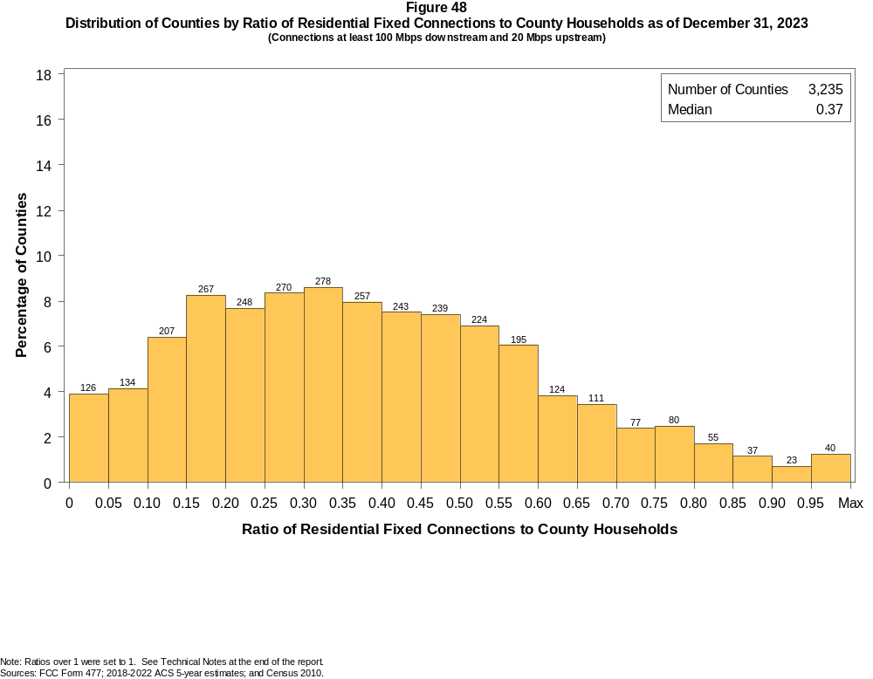

Figure 49
Distribution of Counties by Ratio of Residential Fixed Connections to Households by Technology as of December 31, 2023
(Connections at least 100 Mbps downstream and 20 Mbps upstream)

 | Ratio of Residential Fixed Connections to County Households
Technology | Zero | > 0.00  and  ≤ 0.05 | > 0.05  and  ≤ 0.10 | > 0.10  and  ≤ 0.20 | > 0.20  and  ≤ 0.30 | > 0.30  and  ≤ 0.40 | > 0.40  and  ≤ 0.50 | > 0.50  and  ≤ 0.60 | > 0.60  and  ≤ 0.80 | > 0.80  and  ≤ 1.00 | > 1.00
Total | 0.7 | 3.2 | 4.1 | 14.7 | 16.0 | 16.5 | 14.9 | 13.0 | 12.1 | 4.0 | 0.8
Copper Wire¹ | 58.2 | 38.1 | 2.6 | 1.0 | 0.1 | 0.0 | 0.0 | 0.0 | 0.0 | 0.0 | 0.0
Coaxial Cable | 14.3 | 8.9 | 13.0 | 25.6 | 18.9 | 11.4 | 4.9 | 1.9 | 0.9 | 0.1 | 0.1
Optical Carrier | 4.9 | 25.7 | 13.8 | 19.4 | 12.2 | 8.3 | 5.8 | 3.8 | 3.6 | 2.2 | 0.3
Satellite | 81.2 | 18.8 | 0.0 | 0.0 | 0.0 | 0.0 | 0.0 | 0.0 | 0.0 | 0.0 | 0.0
Fixed Wireless | 8.8 | 88.5 | 1.7 | 0.6 | 0.3 | 0.0 | 0.0 | 0.0 | 0.0 | 0.0 | 0.0
Licensed | 10.9 | 87.9 | 0.8 | 0.3 | 0.2 | 0.0 | 0.0 | 0.0 | 0.0 | 0.0 | 0.0
Unlicensed | 62.6 | 36.2 | 0.8 | 0.3 | 0.1 | 0.0 | 0.0 | 0.0 | 0.0 | 0.0 | 0.0
¹ Other is summarized with Copper Wire for confidentiality reasons.
Note: Each cell indicates the share of 3,235 counties where the ratio of residential fixed connections to households falls within the given range. Numbers may not sum to totals due to rounding.
Sources: FCC Form 477; 2018-2022 ACS 5-year estimates; and Census 2010.

Figure 50
Distribution of Counties by Ratio of Residential Fixed Connections to Households by State as of December 31, 2023
(Connections at least 100 Mbps downstream and 20 Mbps upstream)

 |  | Ratio of Residential Fixed Connections to County Households
State | Counties | Zero | > 0.00  and  ≤ 0.05 | > 0.05  and  ≤ 0.10 | > 0.10  and  ≤ 0.20 | > 0.20  and  ≤ 0.30 | > 0.30  and  ≤ 0.40 | > 0.40  and  ≤ 0.50 | > 0.50  and  ≤ 0.60 | > 0.60  and  ≤ 0.80 | > 0.80  and  ≤ 1.00 | > 1.00
Alabama | 67 | 0 | 6 | 5 | 14 | 12 | 11 | 8 | 8 | 3 | 0 | 0
Alaska | 30 | 7 | 2 | 4 | 1 | 4 | 2 | 3 | 3 | 4 | 0 | 0
American Samoa | 5 | 5 | 0 | 0 | 0 | 0 | 0 | 0 | 0 | 0 | 0 | 0
Arizona | 15 | 0 | 1 | 1 | 1 | 2 | 2 | 4 | 4 | 0 | 0 | 0
Arkansas | 75 | 0 | 1 | 1 | 5 | 11 | 18 | 17 | 10 | 10 | 2 | 0
California | 58 | 0 | 4 | 3 | 7 | 3 | 11 | 14 | 12 | 3 | 0 | 1
Colorado | 64 | 0 | 5 | 5 | 15 | 12 | 4 | 9 | 13 | 1 | 0 | 0
Connecticut | 9 | 0 | 0 | 0 | 0 | 0 | 0 | 1 | 4 | 4 | 0 | 0
Delaware | 3 | 0 | 0 | 0 | 0 | 0 | 0 | 0 | 0 | 2 | 1 | 0
District of Columbia | 1 | 0 | 0 | 0 | 0 | 0 | 0 | 0 | 0 | 1 | 0 | 0
Florida | 67 | 0 | 1 | 5 | 8 | 13 | 7 | 4 | 14 | 15 | 0 | 0
Georgia | 159 | 2 | 2 | 5 | 16 | 25 | 26 | 22 | 33 | 24 | 4 | 0
Guam | 1 | 0 | 1 | 0 | 0 | 0 | 0 | 0 | 0 | 0 | 0 | 0
Hawaii | 5 | 0 | 0 | 0 | 1 | 0 | 0 | 1 | 2 | 1 | 0 | 0
Idaho | 44 | 0 | 6 | 5 | 6 | 5 | 9 | 2 | 8 | 2 | 1 | 0
Illinois | 102 | 0 | 1 | 1 | 10 | 19 | 33 | 28 | 5 | 5 | 0 | 0
Indiana | 92 | 0 | 0 | 2 | 7 | 14 | 25 | 23 | 14 | 6 | 1 | 0
Iowa | 99 | 0 | 0 | 1 | 5 | 6 | 23 | 27 | 24 | 11 | 1 | 1
Kansas | 105 | 0 | 2 | 2 | 18 | 22 | 16 | 17 | 14 | 13 | 1 | 0
Kentucky | 120 | 0 | 0 | 2 | 23 | 17 | 21 | 19 | 17 | 12 | 8 | 1
Louisiana | 64 | 0 | 5 | 5 | 21 | 9 | 8 | 8 | 5 | 3 | 0 | 0
Maine | 16 | 0 | 0 | 1 | 7 | 6 | 2 | 0 | 0 | 0 | 0 | 0
Maryland | 24 | 0 | 0 | 0 | 0 | 1 | 2 | 5 | 2 | 11 | 3 | 0
Massachusetts | 14 | 0 | 0 | 0 | 0 | 1 | 1 | 2 | 4 | 4 | 0 | 2
Michigan | 83 | 0 | 0 | 8 | 24 | 23 | 17 | 8 | 3 | 0 | 0 | 0
Minnesota | 87 | 0 | 1 | 1 | 9 | 14 | 21 | 18 | 13 | 8 | 1 | 1
Mississippi | 82 | 0 | 7 | 2 | 8 | 9 | 11 | 12 | 14 | 16 | 2 | 1
Missouri | 115 | 0 | 11 | 8 | 19 | 18 | 19 | 12 | 11 | 15 | 1 | 1
Montana | 56 | 0 | 7 | 10 | 13 | 8 | 1 | 2 | 5 | 8 | 1 | 1
Nebraska | 93 | 1 | 8 | 5 | 8 | 11 | 13 | 21 | 17 | 7 | 2 | 0

Figure 50 - Continued
Distribution of Counties by Ratio of Residential Fixed Connections to Households by State as of December 31, 2023
(Connections at least 100 Mbps downstream and 20 Mbps upstream)

 |  | Ratio of Residential Fixed Connections to County Households
State | Counties | Zero | > 0.00  and  ≤ 0.05 | > 0.05  and  ≤ 0.10 | > 0.10  and  ≤ 0.20 | > 0.20  and  ≤ 0.30 | > 0.30  and  ≤ 0.40 | > 0.40  and  ≤ 0.50 | > 0.50  and  ≤ 0.60 | > 0.60  and  ≤ 0.80 | > 0.80  and  ≤ 1.00 | > 1.00
Nevada | 17 | 1 | 2 | 2 | 2 | 4 | 3 | 0 | 2 | 1 | 0 | 0
New Hampshire | 10 | 0 | 0 | 0 | 1 | 1 | 0 | 2 | 3 | 2 | 0 | 1
New Jersey | 21 | 0 | 0 | 0 | 0 | 0 | 1 | 0 | 4 | 12 | 4 | 0
New Mexico | 33 | 0 | 4 | 1 | 6 | 6 | 4 | 5 | 1 | 4 | 2 | 0
New York | 62 | 0 | 0 | 0 | 5 | 26 | 10 | 8 | 3 | 4 | 5 | 1
North Carolina | 100 | 0 | 0 | 3 | 13 | 23 | 17 | 19 | 9 | 10 | 5 | 1
North Dakota | 53 | 0 | 0 | 0 | 0 | 0 | 0 | 0 | 1 | 13 | 33 | 6
Northern Mariana Isl | 4 | 4 | 0 | 0 | 0 | 0 | 0 | 0 | 0 | 0 | 0 | 0
Ohio | 88 | 0 | 0 | 4 | 28 | 23 | 14 | 11 | 4 | 4 | 0 | 0
Oklahoma | 77 | 0 | 2 | 1 | 13 | 11 | 14 | 12 | 12 | 6 | 6 | 0
Oregon | 36 | 0 | 1 | 0 | 7 | 8 | 13 | 3 | 3 | 1 | 0 | 0
Pennsylvania | 67 | 0 | 0 | 0 | 3 | 9 | 14 | 13 | 15 | 13 | 0 | 0
Puerto Rico | 78 | 1 | 9 | 9 | 39 | 15 | 5 | 0 | 0 | 0 | 0 | 0
Rhode Island | 5 | 0 | 0 | 0 | 0 | 0 | 0 | 0 | 0 | 5 | 0 | 0
South Carolina | 46 | 0 | 0 | 1 | 5 | 10 | 3 | 8 | 8 | 8 | 1 | 2
South Dakota | 66 | 0 | 0 | 0 | 3 | 1 | 3 | 4 | 6 | 20 | 27 | 2
Tennessee | 95 | 0 | 0 | 0 | 7 | 12 | 16 | 14 | 11 | 31 | 3 | 1
Texas | 254 | 0 | 11 | 11 | 37 | 45 | 41 | 39 | 33 | 29 | 8 | 0
Utah | 29 | 0 | 0 | 0 | 2 | 4 | 2 | 2 | 7 | 9 | 2 | 1
Vermont | 14 | 0 | 0 | 0 | 2 | 5 | 3 | 3 | 0 | 1 | 0 | 0
Virgin Islands | 3 | 0 | 0 | 1 | 2 | 0 | 0 | 0 | 0 | 0 | 0 | 0
Virginia | 133 | 0 | 2 | 6 | 11 | 17 | 23 | 21 | 26 | 23 | 3 | 1
Washington | 39 | 0 | 2 | 3 | 3 | 7 | 7 | 9 | 4 | 3 | 0 | 1
West Virginia | 55 | 1 | 0 | 5 | 10 | 7 | 13 | 10 | 6 | 3 | 0 | 0
Wisconsin | 72 | 0 | 0 | 5 | 22 | 13 | 18 | 11 | 1 | 1 | 1 | 0
Wyoming | 23 | 0 | 0 | 0 | 7 | 6 | 8 | 1 | 1 | 0 | 0 | 0
Total | 3,235 | 22 | 104 | 134 | 474 | 518 | 535 | 482 | 419 | 392 | 129 | 26
Note: Numbers may not sum to totals due to rounding.
Sources: FCC Form 477; 2018-2022 ACS 5-year estimates; and Census 2010.

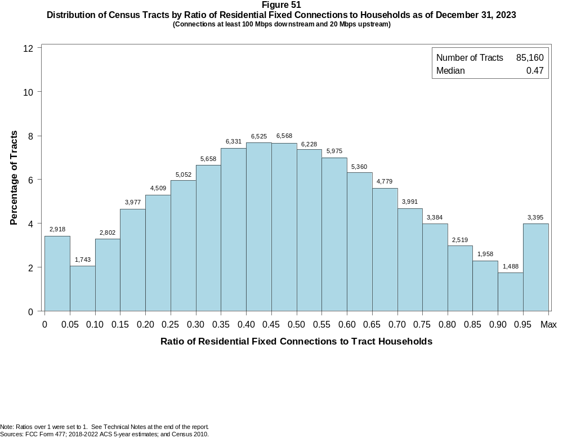

Figure 52
Distribution of Census Tracts by Ratio of Residential Fixed Connections to Households by Technology as of December 31, 2023
(Connections at least 100 Mbps downstream and 20 Mbps upstream)

 | Ratio of Residential Fixed Connections to Tract Households
Technology | Zero | > 0.00  and  ≤ 0.05 | > 0.05  and  ≤ 0.10 | > 0.10  and  ≤ 0.20 | > 0.20  and  ≤ 0.30 | > 0.30  and  ≤ 0.40 | > 0.40  and  ≤ 0.50 | > 0.50  and  ≤ 0.60 | > 0.60  and  ≤ 0.80 | > 0.80  and  ≤ 1.00 | > 1.00
Total | 1.3 | 2.1 | 2.0 | 8.0 | 11.2 | 14.1 | 15.4 | 14.3 | 20.6 | 8.2 | 2.8
Copper Wire¹ | 63.0 | 35.0 | 1.6 | 0.4 | 0.0 | 0.0 | 0.0 | 0.0 | 0.0 | 0.0 | 0.0
Coaxial Cable | 5.8 | 4.1 | 5.0 | 20.6 | 27.3 | 18.1 | 9.6 | 4.8 | 3.5 | 0.7 | 0.4
Optical Carrier | 19.1 | 18.3 | 9.4 | 14.9 | 11.9 | 8.9 | 6.3 | 4.7 | 4.5 | 1.4 | 0.7
Satellite | 99.0 | 1.0 | 0.0 | 0.0 | 0.0 | 0.0 | 0.0 | 0.0 | 0.0 | 0.0 | 0.0
Fixed Wireless | 10.2 | 85.8 | 3.0 | 0.7 | 0.1 | 0.1 | 0.0 | 0.0 | 0.0 | 0.0 | 0.0
Licensed | 11.0 | 86.1 | 2.4 | 0.4 | 0.1 | 0.0 | 0.0 | 0.0 | 0.0 | 0.0 | 0.0
Unlicensed | 91.5 | 7.7 | 0.4 | 0.2 | 0.1 | 0.0 | 0.0 | 0.0 | 0.0 | 0.0 | 0.0
¹ Other is summarized with Copper Wire for confidentiality reasons.
Note: Each cell indicates the share of 85,160 Census Tracts where the ratio of residential fixed connections to households falls within the given range. Numbers may not sum to totals due to rounding.
Sources: FCC Form 477; 2018-2022 ACS 5-year estimates; and Census 2010.

Figure 53
Distribution of Census Tracts by Ratio of Residential Fixed Connections to Households by State as of December 31, 2023
(Connections at least 100 Mbps downstream and 20 Mbps upstream)

 |  | Ratio of Residential Fixed Connections to Tract Households
State | Tracts | Zero | > 0.00  and  ≤ 0.05 | > 0.05  and  ≤ 0.10 | > 0.10  and  ≤ 0.20 | > 0.20  and  ≤ 0.30 | > 0.30  and  ≤ 0.40 | > 0.40  and  ≤ 0.50 | > 0.50  and  ≤ 0.60 | > 0.60  and  ≤ 0.80 | > 0.80  and  ≤ 1.00 | > 1.00
Alabama | 1,435 | 12 | 87 | 62 | 178 | 225 | 234 | 184 | 153 | 204 | 65 | 31
Alaska | 177 | 23 | 17 | 10 | 5 | 5 | 19 | 15 | 33 | 40 | 5 | 5
American Samoa | 18 | 18 | 0 | 0 | 0 | 0 | 0 | 0 | 0 | 0 | 0 | 0
Arizona | 1,765 | 55 | 101 | 38 | 101 | 161 | 215 | 266 | 278 | 391 | 99 | 60
Arkansas | 823 | 2 | 17 | 23 | 97 | 111 | 123 | 133 | 109 | 139 | 57 | 12
California | 9,107 | 80 | 130 | 85 | 321 | 801 | 1,552 | 1,816 | 1,806 | 1,999 | 381 | 136
Colorado | 1,447 | 18 | 53 | 37 | 87 | 130 | 241 | 341 | 241 | 235 | 41 | 23
Connecticut | 879 | 6 | 0 | 1 | 8 | 45 | 72 | 96 | 149 | 347 | 137 | 18
Delaware | 259 | 3 | 0 | 0 | 2 | 9 | 15 | 23 | 33 | 89 | 47 | 38
District of Columbia | 206 | 2 | 0 | 0 | 0 | 5 | 20 | 29 | 41 | 77 | 24 | 8
Florida | 5,114 | 51 | 61 | 60 | 261 | 554 | 704 | 838 | 816 | 1,115 | 351 | 303
Georgia | 2,791 | 18 | 37 | 38 | 144 | 241 | 352 | 425 | 467 | 721 | 288 | 60
Guam | 56 | 10 | 26 | 16 | 2 | 1 | 0 | 0 | 0 | 0 | 0 | 1
Hawaii | 436 | 13 | 8 | 2 | 9 | 35 | 58 | 85 | 85 | 91 | 20 | 30
Idaho | 456 | 2 | 36 | 18 | 38 | 24 | 32 | 64 | 79 | 114 | 30 | 19
Illinois | 3,263 | 10 | 42 | 47 | 211 | 592 | 821 | 737 | 497 | 278 | 25 | 3
Indiana | 1,693 | 10 | 16 | 29 | 106 | 251 | 360 | 346 | 268 | 238 | 54 | 15
Iowa | 896 | 5 | 9 | 21 | 49 | 76 | 110 | 139 | 156 | 228 | 77 | 26
Kansas | 829 | 14 | 15 | 52 | 79 | 64 | 88 | 91 | 108 | 216 | 78 | 24
Kentucky | 1,306 | 11 | 19 | 45 | 151 | 184 | 162 | 188 | 194 | 242 | 88 | 22
Louisiana | 1,376 | 32 | 97 | 84 | 252 | 185 | 183 | 203 | 131 | 164 | 38 | 7
Maine | 400 | 0 | 9 | 17 | 144 | 129 | 55 | 25 | 15 | 3 | 2 | 1
Maryland | 1,463 | 7 | 2 | 2 | 15 | 80 | 119 | 166 | 177 | 461 | 367 | 67
Massachusetts | 1,613 | 20 | 3 | 4 | 59 | 135 | 133 | 234 | 301 | 486 | 203 | 35
Michigan | 2,971 | 81 | 47 | 83 | 405 | 618 | 625 | 599 | 347 | 138 | 23 | 5
Minnesota | 1,502 | 4 | 37 | 34 | 138 | 188 | 341 | 315 | 205 | 174 | 52 | 14
Mississippi | 875 | 9 | 49 | 31 | 93 | 79 | 98 | 101 | 93 | 191 | 105 | 26
Missouri | 1,654 | 10 | 103 | 57 | 167 | 164 | 212 | 213 | 268 | 337 | 94 | 29
Montana | 319 | 10 | 37 | 36 | 68 | 74 | 36 | 15 | 11 | 21 | 5 | 6
Nebraska | 553 | 3 | 16 | 12 | 25 | 53 | 55 | 84 | 106 | 157 | 31 | 11

Figure 53 - Continued
Distribution of Census Tracts by Ratio of Residential Fixed Connections to Tract Households by State as of December 31, 2023
(Connections at least 100 Mbps downstream and 20 Mbps upstream)

 |  | Ratio of Residential Fixed Connections to Tract Households
State | Tracts | Zero | > 0.00  and  ≤ 0.05 | > 0.05  and  ≤ 0.10 | > 0.10  and  ≤ 0.20 | > 0.20  and  ≤ 0.30 | > 0.30  and  ≤ 0.40 | > 0.40  and  ≤ 0.50 | > 0.50  and  ≤ 0.60 | > 0.60  and  ≤ 0.80 | > 0.80  and  ≤ 1.00 | > 1.00
Nevada | 775 | 5 | 13 | 16 | 52 | 65 | 105 | 126 | 88 | 193 | 76 | 36
New Hampshire | 349 | 2 | 2 | 5 | 15 | 19 | 40 | 68 | 91 | 69 | 18 | 20
New Jersey | 2,175 | 10 | 4 | 9 | 6 | 25 | 49 | 131 | 291 | 849 | 668 | 133
New Mexico | 612 | 25 | 47 | 31 | 110 | 150 | 104 | 64 | 35 | 30 | 11 | 5
New York | 5,393 | 140 | 16 | 22 | 521 | 595 | 655 | 562 | 550 | 1,294 | 839 | 199
North Carolina | 2,660 | 23 | 27 | 44 | 296 | 376 | 369 | 315 | 332 | 502 | 225 | 151
North Dakota | 228 | 2 | 0 | 0 | 0 | 0 | 1 | 5 | 16 | 72 | 99 | 33
Northern Mariana Isl | 23 | 23 | 0 | 0 | 0 | 0 | 0 | 0 | 0 | 0 | 0 | 0
Ohio | 3,162 | 13 | 31 | 97 | 509 | 570 | 441 | 460 | 390 | 491 | 136 | 24
Oklahoma | 1,205 | 17 | 43 | 50 | 95 | 118 | 174 | 194 | 164 | 237 | 82 | 31
Oregon | 994 | 5 | 20 | 25 | 105 | 150 | 183 | 195 | 133 | 143 | 33 | 2
Pennsylvania | 3,445 | 47 | 15 | 29 | 161 | 266 | 412 | 610 | 574 | 932 | 356 | 43
Puerto Rico | 939 | 86 | 144 | 126 | 268 | 144 | 95 | 37 | 21 | 10 | 5 | 3
Rhode Island | 247 | 1 | 1 | 0 | 0 | 0 | 7 | 23 | 46 | 133 | 33 | 3
South Carolina | 1,317 | 12 | 17 | 18 | 151 | 160 | 167 | 207 | 172 | 219 | 109 | 85
South Dakota | 242 | 0 | 0 | 3 | 9 | 5 | 13 | 11 | 14 | 71 | 92 | 24
Tennessee | 1,701 | 27 | 13 | 15 | 136 | 198 | 253 | 238 | 227 | 391 | 157 | 46
Texas | 6,883 | 60 | 140 | 136 | 546 | 616 | 746 | 958 | 962 | 1,651 | 698 | 370
Utah | 716 | 9 | 5 | 3 | 22 | 46 | 84 | 106 | 135 | 196 | 78 | 32
Vermont | 193 | 1 | 10 | 8 | 28 | 21 | 44 | 35 | 16 | 17 | 5 | 8
Virgin Islands | 29 | 0 | 7 | 7 | 13 | 2 | 0 | 0 | 0 | 0 | 0 | 0
Virginia | 2,186 | 25 | 40 | 34 | 97 | 180 | 201 | 259 | 266 | 633 | 389 | 62
Washington | 1,772 | 9 | 66 | 32 | 82 | 183 | 353 | 374 | 285 | 296 | 59 | 33
West Virginia | 546 | 8 | 27 | 25 | 55 | 62 | 72 | 107 | 87 | 93 | 10 | 0
Wisconsin | 1,526 | 2 | 57 | 58 | 255 | 346 | 349 | 222 | 131 | 90 | 9 | 7
Wyoming | 160 | 1 | 7 | 6 | 32 | 45 | 37 | 15 | 10 | 6 | 1 | 0
Total | 85,160 | 1,092 | 1,826 | 1,743 | 6,779 | 9,561 | 11,989 | 13,093 | 12,203 | 17,514 | 6,975 | 2,385
Note: Numbers may not sum to totals due to rounding.
Sources: FCC Form 477; 2018-2022 ACS 5-year estimates; and Census 2010.

